November 17, 2008

Mary Nichols
Chair, California Air Resources Board
1001 I Street
P.O. Box 2815
Sacramento, CA 95814

RE: Town of Apple Valley Comments on Air Resources Board Proposed Scoping Plan

Dear Chair Nichols:

On behalf of the Town of Apple Valley, thank you for the opportunity to comment on the California Air Resources Board’s (ARB) Proposed Scoping Plan (Scoping Plan).

The Town of Apple Valley is proud of the work it has done already on reducing greenhouse gas (GHG) emissions. The Green Apple Program is a plan to help our community reduce, reuse, recycle and renew. This plan offers a number of programs for Apple Valley residents to lessen the impact on the environment.

While the Town of Apple Valley is generally supportive of a number of programs and policies outlined in the Scoping Plan, it is crucial for state policymakers take account for the means that will be needed to achieve the goals. AB 32 requires that reductions in GHG emissions must achieve the maximum technologically feasible and cost effective reductions and for the ARB to “consider the cost-effectiveness of these regulations.” (HSC §38560) In addition, we believe that the Scoping Plan appropriately allow the SB 375 process to develop regional transportation-related GHG targets. Implementation of the regional planning processes in SB 375 is new and largely untested. The 5 MMT figure, while a place holder; nevertheless sets an appropriate benchmark that helps assure that the state can achieve its overall 2020 goal.”

As both the state and local governments are faced with critical budget shortages, additional costs to heavily invest in GHG emission technologies in the next 2 to 3 years will become more burdensome for local governments. While local governments can influence development design to a certain extent, the reality is that developers will only build projects that will be purchased by willing customers and that are profitable. In order to effect the desired change, incentives must be provided to the development community and local agencies in order to encourage more development in areas where the reductions in GHG emissions will be the greatest. The Town of Apple Valley strongly encourages the ARB to consider these limitations as it moves forward with the Scoping Plan.
Given the current status of the state and national economy, the limited resources and diverting of tax revenue by the state, another option would be to delay implementation until significant improvement in the state economy occurs.

Thank you again for the opportunity to comment. The Town of Apple Valley looks forward to working with the ARB in the future.

Sincerely,

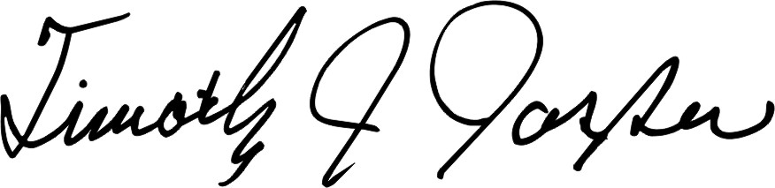

Timothy J. Jasper
Mayor

TJJ:lm

cc: Senator George Runner
Assemblyman Anthony Adams
Town Council
Nancy Cisneros, Regional Representative
Robyn Black, Aaron Read and Associates

