California Forestry Association
1215 K Street, Suite 1830
Sacramento, CA 95814
(916) 444-6592 fax (916) 444-0170
e-mail: cfa@foresthealth.org web site: www.foresthealth.org

November 11, 2008
Mary Nichols, Chair
California Air Resources Board
P.O. Box 2815
Sacramento, CA 95812-2815

Re: AB 32 Scoping Plan

Dear Chair Nichols:

The California Forestry Association (CFA) appreciates this opportunity to comment on the proposed AB 32 Scoping Plan (Plan) that the Air Resources Board (ARB) will consider for endorsement at its December 11-12, 2008 Board meeting.
CFA is a trade association whose members consist of California forest products producers, forest landowners and natural resource professionals committed to environmentally sound policies, responsible forestry, and sustainable use of California’s natural resources. Our members process over 90 percent of the wood products manufactured in the state of California.
While our comments focus primarily on the Forest Sector of the Plan and its Appendices, we also discuss opportunities associated with use of forest biomass as feedstock for biomass power and biofuels, which resides primarily in the Energy Sector. We will also briefly touch on Cap and Trade and auctions, and finally, page specific comments to the Plan and its Appendices.

General Comments

Before commenting, CFA would like to express to you how pleased we are that the ARB has engaged the Board of Forestry (BoF) on the appropriate expectation of net emissions reduction from the Forest Sector by 2020. While the ARB is ultimately responsible for achieving the reductions, the BoF has the authority – and expertise – to develop, revise and implement regulations and programs to assure that the Forest Sector target is met. We endorse the findings of the BoF. We conclude, as did the BoF, that the Forest Sector can maintain the -5 million metric ton carbon dioxide equivalent (MMT CO2e) and can surpass that level of net sink through a combination of regulatory, statutory and incentive-based approaches and elimination of existing barriers. Further, dramatic additional emission reductions could be possible with policy changes by the Federal Government that would lead to rapid increases in fuels reduction on the National Forests.

ARB must develop a Scoping Plan that will reduce emissions by 169 MMT CO2e. Further, Executive Order S-3-05 requires reduction of an additional 342 MMT CO2e by 2050. Every opportunity must be explored, including the opportunities the forest sector and biomass renewable energy can provide. CFA has demonstrated to ARB (Emission Reduction Form submitted to ARB September 9, 2007) that the Forest Sector has the opportunity to provide not just -5 MMT CO2e, but an additional -50 MMT CO2e through appropriate regulatory, statutory, and incentive-based approaches. We believe that beyond year 2020, the State will need an additional -50 MMT CO2e from the Forest Sector and from biomass renewable energy to achieve the 2050 goal. Since Forestry is a long term endeavor, the time to act is now.

Actively managed forests provide tremendous co-benefits to the environment including but not limited to:

- A renewable resource that absorbs carbon in tree growth;
- Storing carbon in long term solid wood products;
- Providing a fossil fuel energy offset by utilizing renewable solid wood products for building materials in lieu of energy intensive steel, aluminum, concrete, vinyl and plastic non-renewable products;
- Providing wood byproducts that can be and are used for electricity generation, and, likely within 5 to 7 years, commercially viable biofuels;
- Reducing wildfires, wildfire emissions, and fire suppression costs;
- Providing sustainable quality wildlife habitat and abundant clean, cold water; and
- Providing economic vitality, particularly in rural communities, through sustainable job creation and the associated indirect benefits of supporting service sector jobs.

California has 33 million acres of forestland of which 19.5 million acres are productive and suitable to be actively managed. The Forest Service manages 9.8 million acres of productive forestland in the State; private lands contain 8.6 million acres of productive forestland. About 97 percent of our old growth in California is protected in public ownership. California’s privately-owned forests are growing 170 percent more wood than is harvested and plant seven seedlings for every tree harvested.

While some suggest that a “do-nothing” approach in the forest is the answer to maximizing carbon sequestration, CFA believes this is a dangerous strategy. If our forests are not actively managed, they will continue to get denser, exceeding the capacity of the landscape and eventually succumb to insects, disease, and catastrophic wildfires. Certainly storing carbon through tree growth is one way to absorb more and more carbon dioxide from the atmosphere; however, nearly all vegetative types in California are fire-adapted ecosystems. Managing vegetative stocks can provide healthy forests that are resistant to insects, disease and wildfire reducing the intensity and acres burned in large wildfires and reducing the associated suppression costs.

As we will show below, we conclude that California’s forests do provide opportunities to achieve additional net carbon sequestration, and the other benefits mentioned above, but it cannot be done without public lands being actively managed primarily because of the ever-increasing risk of wildfire.

Wildfires

As the Scoping Plan recognizes, there are risks of natural disturbances that can quickly turn the Forest Sector from a net sink to a net source. In March 2006, California’s Climate Action Team (CAT) concluded that by the end of this century, California could face longer, hotter, dryer summers, up to a 90 percent reduction in spring snowpack, and up to a 55 percent increase in large wildfires (www.energy.ca.gov/2006publications/CEC-500-2006-077/CEC-500-2006-077.PDF).

Of the 85 million acres of vegetated areas statewide, CALFIRE’s FRAP database indicates:

- 30.4 million acres have a high threat of wildfire
- 15.8 million acres have a Very High threat of wildfire, and
- 2.2 million acres have an Extreme threat of wildfire.

From 1950 to 2000, California experienced several years of large areas burned averaging from 500,000 to 700,000 acres (see CDF, FRAP table below). In 2007, California experienced over 1 million acres burned statewide and in 2008 the State has experienced over 1.2 million acres burned. The CAT predictions on increased wildfire have arrived about 90 years early.
Annual area burned*, statewide, 1950 - 2000
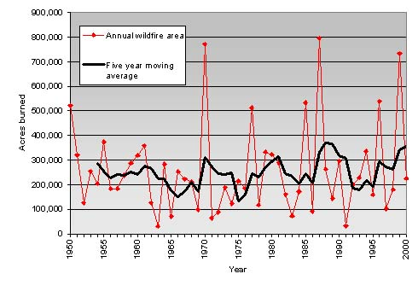
Unfortunately the emissions from these wildfires are enormous (as well as property damage and suppression costs). The California In-State emissions inventory has estimated wildfire emissions 1990-2004 at 2 MMT CO2e. Dr. Tom Bonnicksen, ARB, and National Center for Atmospheric Research estimated the Southern California Fires of 2007 (1/2 of the acres burned statewide that year) at 19, 6, and 8.7 MMT CO2e respectively. Clearly managing vegetation so that it is healthy and thus resistant to insects, disease and wildfire are of extreme importance to attain a 169 MMT CO2e AB 32 emissions reduction by year 2020. Without adjustments in policies, procedures, incentives, and removing barriers particularly on the National Forests, the 169 MMT CO2e figure will rise dramatically and the reductions will have to be increased in other In-State Sectors.

Forest Carbon Sequestration

California’s forests, particularly its National Forests, have the capability of nearly doubling net growth. With a fivefold increase in fuels reduction, California’s National Forests could return to healthy conditions resistant to insects, disease and wildfire. Forest Service researchers say that with thinned forests we can expect at least a 50-60 percent reduction in large wildfires rather than the predicted 55 percent increase. California’s privately-owned forests are growing 170 percent more wood than is harvested and planting seven trees for each tree cut. And, we know, that healthy forests provide many co-benefits including abundant, quality wildlife habitat, intact watersheds, clean, cold water, aesthetic enjoyment, and economic stability to rural counties.

Substitution – Wood Products in lieu of Non-Renewable Building Materials

Wood is Good! Fossil fuel energy requirements for non-renewable building materials (steel, aluminum, concrete, plastic, vinyl,) are at least double or more than for an equivalent wood product. A renewable energy credit for using wood in the voluntary carbon marketing arena will help provide incentives for active forest management. However, much more can be done. California can greatly reduce its imports of building materials by utilizing the wood that is grown in-state. Forest growth in California is over 8 billion board feet yet harvest levels are currently less than 2 billion board feet.

Bioenergy

California’s own “Roadmap” to bioenergy production demonstrates the availability of feedstock and calls for a fivefold increase in biomass power generation in the State. Major opportunities for in-state biomass development include: expansion to nearly 2,500 megawatts of electric power and 18 billion kilowatt-hours of electrical energy, one to two billion gallons per year of biofuels, 100 billion cubic feet of biomethane, and more than a million tons per year of hydrogen (CEC-500-2006-095-D November 2006, p. xi).

There’s a 98% reduction in emissions if forest biomass is used as a feedstock for biomass powerplants rather than open burned. There’s also at least a net reduction of 1 ton of GHG emissions for every 1 bone dry ton of forest biomass used to generate power when compared to a coal or natural gas-fired
plant.

Biomass incentives – The State could do a multitude of things to provide incentives for biomass-created electricity including but not limited to: 1) a 50 percent investment tax credit for new and retrofits and upgrades to existing powerplants, 2) a $10 tax credit for every green ton of feedstock transported and used in a biomass powerplant or biofuels plant, and 3) the California Public Utilities Commission directing an increase in existing and new fixed price power purchase agreements from 6.4 to 10 cents/kilowatt. The Western Governors Association (WGA) has demonstrated there is at least an 11 cent/kilowatt uncompensated social and environmental benefit from use of wood to generate power (WGA Biomass Taskforce Report, January 2006). Incentives are needed now. Since the California Renewable Portfolio Standard was instituted in 2004, the percentage of electricity generation from renewables has declined every year.
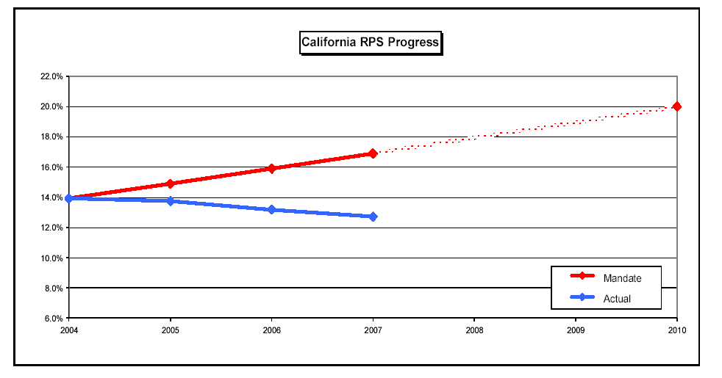

Finally, biogenic CO2 should not be subjected to a cap and trade program. The proposed Plan does not differentiate between biogenic and anthropogenic CO2. It must do so. Biogenic CO2 for power generation should be incentivized because: 1) it displaces fossil fuel produced energy and 2) it utilizes biomass material that would otherwise be open-burned or placed in landfills. Further, the Western Climate Initiative (WCI) recommends a threshold applicable to electricity generation of 25,000 metric tons of “anthropogenic” CO2e annually as the level for inclusion in a regulatory compliance obligation under a cap and trade program (WCI, “Design Recommendations for the WCI Regional Cap-and-Trade Program September 23, 2008, p.3).

Leakage

AB 32 is constructed off of an “In-State” emissions inventory that, except for the electricity sector, ignores leakage. California currently imports about 75 percent of the wood products it consumes and 30 percent of its electricity. By actively promoting the “CA GROWN” campaign for solid forest products and bioenergy in your Plan, ARB could facilitate increased consumption of wood grown and produced in our state. This policy would not only be good for the environment, but also our struggling economy. Your Plan accounts for and addresses leakage in the Electricity Sector. Every one of California’s 165 Sectors should also address leakage. Once addressed in the Plan, state agencies would be compelled to develop policies and regulations addressing emissions from California consumption.

Page Specific Comments

P. 35 -- Auction

Should cap and trade be instituted, any amount of allowances that are auctioned produce revenue that by definition the Government has decided they know best how to achieve greater emissions reduction than if they had not auctioned some of the allowances. If these revenues are not 100 percent utilized in a manner that will lead to greater emissions reductions, than the auction is nothing more than a TAX. CFA does not support auctions of any allowances. However, if some level of auction is applied, all of the revenues should have an emissions reduction accomplishment tied to them. This would then assure that whatever projects are supported by auctioned revenues will actually lead to more rapid emissions reduction. If the project does not lead to emissions reduction, than the grantee has to pay the money back and is never again granted a project.

C-52 – Scoping Plan Measures; Sustainable Forests –

We would suggest that the first bullet should change the word “conserve” to “that lead to actively managed” forestlands. In the third bullet, we suggest it should read “Make public investment to purchase and actively manage forests and woodlands.”

C-167 – Opportunities for Additional Reductions, 2nd paragraph, 1st sentence – We believe it should read “. . . energy generation and production of biofuels.”

C-169 – Implicating that California’s forestlands have more growing potential than the current 2.4 percent per year statewide is correct but only if the lands are actively managed, particularly the national forests. For the most part, California’s productive forestlands are fire-adapted ecosystems. You simply cannot pack more and more carbon on the landscape indefinitely without the unintended consequence of insects, disease, and wildfire taking over. The current growth rate on California’s national forests is not sustainable. Over 7 million acres of overly dense vegetation on the national forests in California are already at risk to large wildfires and are burning. The Forest Service has over 200,000 acres of high intensity burned areas just since 2000 that they do not have the money to do the site preparation and replanting. This does not include the portion of the 1 million acres of California that burned in 2007 and the 1.2 million acres in 2008 that were high intensity burned areas on the national forests. Hence the national forests are at risk to substantial continuation of large wildfires and then not reforesting, which means the absorption of CO2 from the forest that burned and from the lack of having a future forest absorbing CO2 is lost.

C-169 -- Riparian Zone Extension – If this implies “no cut buffers”, then it is not sustainable without periodic thinning and fuel reduction.

C-169 – Afforestation – This should be explicit for “forestlands”.

C-169 – Timber Stand Improvement – the first sentence should say “. . . incentive for the private landowners and, perhaps, public lands to make the additional investment . . .” It is not yet certain or uncertain as to whether or not public forestlands will have opportunities to be part of carbon marketing.

C-170 – bottom of the page – As CFA demonstrated to ARB back in September 2007, fuels reduction just on the National Forests in California can provide significant net sink increases in sequestration, substitution and use of wood residues and wood waste for electricity generation. If the Forest Service would increase its mechanical fuels reduction accomplishment from the current 100,000 acres/year to 500,000 acres/year and if currently unmanaged non-industrial private lands were managed, the outcome would be at least 18 MMTCO2e additional net sequestration, 28 MMTCO2e in substitution of wood products for non-renewable building materials, and 6.5 MMTCO2e in biomass utilized for electricity generation (substitution and bioenergy would be counted in the energy sector). The State’s own “Roadmap” for bioenergy indicates a potential to increase biomass generated electricity from the current 550 megawatts to 2,500 megawatts. Last, with actively managed forests, particularly the National Forests in California, Forest Service researchers expect that wildfires and their associated emissions could be reduced by 50 to 60 percent or more, along with reduced suppression costs.

C-171 – A new section should be added: “Wildfires” – This would be an excellent location to explain that the current In-State Emissions Inventory assumes wildfires statewide produce 2 MMT CO2e. In 2007, the southern California wildfires (1/2 the total acreage burned in the State that year) were estimated at 6, 8.7, and 19 MMTCO2e by National Center for Atmospheric Research, ARB, and Dr. Tom Bonnicksen, respectively. Wildfires in California burned 1.2 million acres in 2008. The point is that wildfire emissions are “in the wrong direction” on meeting AB32 emissions reduction goals. The Plan believes the target is 169 MMTCO2e emissions reduction by year 2020 when the actual calculation might be more like 185 MMTCO2e or more. If California and the Federal Government do not change policies and procedures that lead to rapidly accelerated rates of fuels reduction on currently unmanaged productive forestlands, wildfires will become the dominant force on the landscape (and may already be). Increased wildfires mean increased emissions, which make the AB32 emission reduction goals a bigger and bigger challenge and would cause the need for bigger emission reductions from other In-State Sectors.

Sincerely,

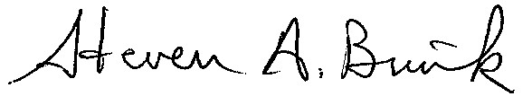
STEVEN A. BRINK
Vice President – Public Resources
California Forestry Association

Cc: George Gentry

Air Resource Board Members

