November 20, 2008

Chairwoman Mary Nichols
California Air Resources Board
1001 "I" Street
P.O. Box 2815
Sacramento, CA 95812

RE: Proposed Scoping Plan and Incorporating Urban Greening

Dear Chairwoman Nichols,

On behalf of TreePeople, an urban forestry nonprofit organization serving the greater Los Angeles area for over 35 years, I would like to commend the Air Resources Board for their hard work and dedication in producing the Proposed Scoping Plan for the implementation of the Global Warming Solutions Act of 2006.

TreePeople is helping to promote urban forests and local watershed management practices both regionally and nationally as mitigation and adaptation methods for responding to the impacts of climate change.

On behalf of TreePeople, I respectfully submit the following comments to the Air Resources Board.

Urban Greening and Climate Change

Urban greening and urban forestry projects provide benefits in addition to carbon sequestration that result in greenhouse gas emission reductions, such as energy conservation and urban heat island mitigation from strategic tree planting.

In addition, a functioning urban forest in an urban watershed can capture a portion of a community’s water needs in an average year, saving money, conserving water, augmenting the local water supply, and reducing pollution and water-related energy.

Lastly, much of the “green waste” that is currently hauled to landfills can be diverted by being left on site for mulch, resulting in reduced greenhouse gas emissions from trucking the green waste to the landfill.

Without counting these benefits, we are missing the largest contributing factors of urban forests to reducing greenhouse gas emissions. We feel strongly that these benefits should be included in the Scoping Plan as they represent real opportunities for reducing greenhouse gas emissions.

Proposed Scoping Plan

We commend the Air Resources Board for including potential avenues for urban forests to play a role in the implementation of AB 32, including offsets, a dedicated use of allowances or set-aside, and through the public goods fee on water.

We were pleased to see the mention of offsets in the Proposed Scoping Plan, which is an opportunity to provide incentives to local governments and other sectors to implement urban greening projects to not only meet their own greenhouse gas emission reduction goal, but to exceed it. When they exceed their target, the extra emission reductions provided by the urban greening projects should be credited to the local government and hold a value on the market. This would require that the Air Resources Board revise and expand the Urban Forest Protocols to include additional greenhouse gas emission reducing benefits aside from sequestration.

We are interested to see how an allowance set-aside for rewarding early actions can serve as an incentive to local governments to engage in projects such as urban greening and urban forestry to reduce emissions. Local governments are the most likely sector to implement urban greening methods, because they see the value in all of the added benefits as well, such as aesthetics, social and economic benefits, soil retention, water quality, recreation, open space, and more.

Scoping Plan Implementation and Climate Change Adaptation

We are prepared to engage in the next phase of implementation of the Proposed Scoping Plan, including the regulatory process, any potential legislative guidance, expanding the Urban Forest Protocols to include additional greenhouse gas emission reduction benefits as offsets, and the proposed public goods fee on water.

In addition, as the Air Resources Board continues to develop the cap and trade system, we would support an auction system where fees would be spent on projects related to climate change, including technology to reduce energy consumption and improve energy efficiency, natural resources and urban sustainability projects, smart green infrastructure, and research and development for additional measures.

Lastly, we would like to raise the issue of climate change adaptation. It is important to not only directly reduce and offset greenhouse gas emissions, but to also plan for adapting to the inevitable effects of climate change facing the state. Complimentary to the Proposed Scoping Plan, there should also be a focus on adaptation methods that use natural systems and natural resources, including urban forests and urban sustainability projects.

We are pleased to work with you to help find a solution to include the many benefits that urban greening and urban forestry provide to reducing greenhouse gas emissions and reaching the goals of AB 32, The Global Warming Solutions Act of 2006.

With warm regards,
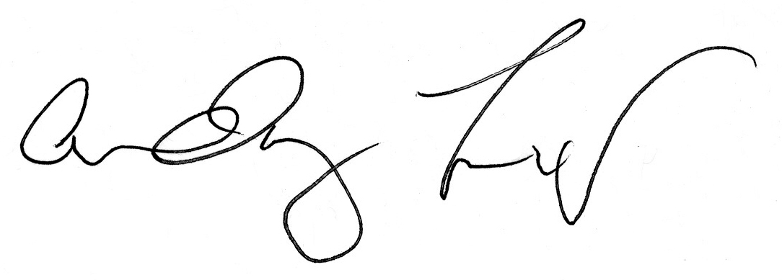

Andy Lipkis
President

