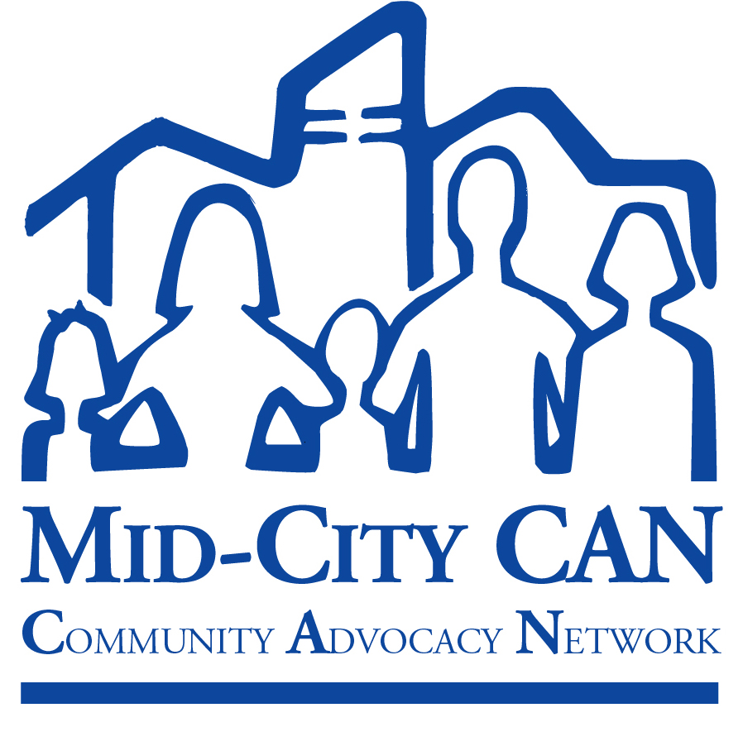
November 19, 2008

RE: Comments on Climate Change Proposed Scoping Plan

Dear Chair Nichols and Members of the California Air Resources Board:

Comprised of over 100 agencies, residents, parents, youth, businesses, schools, and religious institutions serving the neighborhoods of City Heights, Normal Heights, Oak Park, Darnall, Rolando, College Area, Kensington and Talmadge, Mid-City Community Advocacy Network is one of the strongest, most mature and esteemed community collaborations in San Diego County.

We commend the California Air Resources Board (CARB) for its groundbreaking efforts to develop a comprehensive plan to reduce greenhouse gas emissions, and we are very pleased to see that the final version of the Scoping Plan is a significant improvement over the earlier draft.

We applaud the plan’s greater emphasis on the role of land use planning and local government efforts in meeting the greenhouse gas reduction goals:

• The new plan more than doubles the goal for emission reductions from the land use sector (from just 2 million metric tons to 5).
• The plan also calls on local governments to reduce their emission by 15% over projected 2020 emission levels.

We also greatly appreciate the inclusion of the California Department of Public Health (CDPH) as the newest member of the Climate Action Team (CAT).

But before the Board adopts the final plan, we urge you to take the following actions to maximize the public health benefits of the Scoping Plan and protect vulnerable and low-income communities.

1. Establish a formal role for public health in the implementation of AB 32 regulatory and market strategies.
While CARB has tremendous expertise and knowledge about the air quality benefits of global warming strategies, there is a strong need for a broader range of information on health impacts and health benefits of mitigation strategies. It is important that the Scoping Plan include a clear commitment from the Board to reach out to the broad range of health constituencies.
.
We ask that you direct staff to come back within three months with recommendations for establishing a formal process to include state and local public health agencies and organizations in the development and review of all proposed greenhouse gas reduction measures, including proposed regulatory and market mechanisms, so that they can provide input and analysis of the broad range of health benefits and concerns related to those measures.

2. Ensure protection for already over-impacted communities.

Mitigation strategies, such as cap-and-trade programs or siting of new “green” facilities, must not exacerbate already existing health inequities in low-income communities. Such communities are already unequally burdened by extremely poor environmental conditions and poor health. This plan must include adequate safeguards for these communities. City Heights, a low-income community in San Diego, has the among the highest rates of asthma and diabetes in the county, is located between three major interstate freeways, is severely deficient in parkspace, and is the most densely developed in the county. The Board must insure that each measure included in the Scoping Plan will not only assist statewide greenhouse gas reduction goals but will also improve conditions in local communities. This means that the measures must both prevent creation of localized pollution “hot spots” and demonstrate the ability to achieve real improvements in air quality and health conditions in all communities in the state.

We ask that you establish additional measures in the Scoping Plan to identify and ensure protection of vulnerable and low-income communities and prevent any backsliding on air quality protections. This includes directing CARB staff to do the following:

a. Establish within one year a cumulative impacts screening protocol to identify those communities most impacted by air pollution;
b. Design regulator and market-based compliance mechanisms to achieve maximum emission reductions and co-benefits in these communities; and
c. Initiate a public process to determine how resources generated through implementation of AB 32 measures can be allocated to minimize adverse health impacts and create climate resiliency in our most vulnerable communities.

3. Set a higher target for greenhouse gas reductions from the land use sector.
The current target of 5 million metric tons (MMT) does not keep us on track for achieving our 2050 greenhouse gas reduction goals. We need to reduce vehicle miles traveled (VMT) by 10% by 2020, but the current 5 MMT target equates to only a 4% reduction in VMT. By assigning only minimal emission reduction targets to land use and transit policies, CARB misses a critical opportunity to spur meaningful change in the built environment to mitigate climate change and improve the public’s health.

Requiring better land use and transportation planning will reduce greenhouse gas emissions, improve air quality and physical activity levels, and reduce obesity-related illnesses such as diabetes and cardiovascular disease. Twenty-five percent of all development on the ground in 2020 will have been built between 2010 and 2020. This presents a tremendous opportunity to improve the design of new development so that it allows people to choose alternatives to driving and provide access to public transit. When transit is convenient and reliable people use it: 42% of Bay Area residents who live within ½ mile of public transit use it to get to work. When people live in compact, mixed-use communities they drive 30% less that those who live in sprawling suburban developments.

CARB should increase the goal for emissions reductions due to smart land use planning to 11 – 14 MMT. This would send an important signal to create communities that enable people to get our of their cars and walk, bike, or take public transit—improving their own health while improving the health of the planet.

Thank you for considering these suggestions.

Sincerely,

Kevin O'Neill
Director, Mid-City Community Advocacy Network
(Approved by vote of the Coordinating Council)

