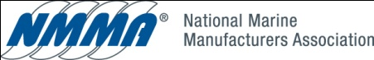
April 3, 2012

Mr. Jeff Lowry
California Air Resources Board
9528 Telstar Ave.
El Monte California 91731

The National Marine Manufacturers Association (NMMA) appreciates the opportunity to provide comments regarding the 15 day modification to the Proposed Regulatory Order Section 2447 titled “California Exhaust Emission Standards and Test Procedures for 2001 Model Year and Later Spark- Ignition marine Engines.”

As Mark Riechers, Mercury Marine and I testified at the board hearing, boaters and other small engine manufacturers have serious concerns with the use of ethanol as a gasoline additive in amounts greater than 10% by volume. Although NMMA members currently design and calibrate their engines to operate both efficiently and cleanly on E10, we are also working closely renewable fuel companies to explore second generation renewable fuels that will hopefully in the future provide all the benefits of gasoline without the negative effects of ethanol.

For these reasons, we support the board amendment to allow for the use of other ARB-certified test fuels, rather than the original staff proposal that would limit renewable fuels development to ethanol only.

Thank you for your support with this issue. If you have any questions please contact me at 202-737-9757 or jmcknight@nmma.org.

Sincerely,

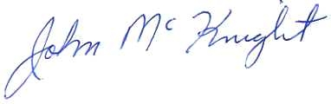

John McKnight, Director
Environmental & Safety Compliance
