February 19, 2010
VIA eLECTRONIC sUBMISSION
California Air Resources Board
Clerk of the Board
1001 I Street
Sacramento, CA 95814

Re: Public Hearing to Consider Amendments to the Current Regulations for Small Off-Road Engines –
15-DAY Notice of Modifications to the ZEE Program

On behalf of the members of the Outdoor Power Equipment Institute (OPEI), I appreciate the opportunity to submit comments to the California Air Resources Board (“ARB”) February 4, 2010, published Notice of Public Availability of Modified Text related to the November 21, 2008 Public Hearing to Consider Amendments to the Current Regulations for Small Off-Road Engines.

OPEI is the international trade association that represents all the major manufacturers of lawn and garden, utility and forestry equipment, including manufacturers of handheld products (like chainsaws, hedge trimmers and blowers), ground-supported products (such as walk-behind lawnmowers) and the manufacturers of clean and powerful engines for these vital landscape maintenance machines. These products maintain and nurture green lawns, landscapes and healthy forests, which in turn provide enormous quality of life, health, and environmental benefits, including the sequestration of carbon dioxide and other green house gas emissions, reductions in storm water runoff, and mitigation of the heat island effect plaguing many of our cities and communities.

I. Background
In OPEI’s November 18th, 2008, written comments to the Air Resources Board in connection with the November 21, 2008 public hearing concerning agenda item 08-10-3, OPEI noted our concerns about the Zero Emission Equipment (ZEE) program at the current level of specificity and policy concerns. In particular, OPEI highlighted concerns with new, high-risk market entrants being able to flood the California market with dirty gasoline powered products using ZEE credits. Additionally, OPEI noted the ambiguities in the product definitions and performance requirements to qualify for ZEE certification, credit generation and credit use. OPEI also recommended that the Board direct ARB Staff to come back with “a more refined proposal, or work through a “15 day” regulatory process with the affected stakeholders, including OPEI, to develop the needed technical amendments and procedures.”
Unfortunately, at the November 21st, 2008 public hearing, the Board approved adoption of amendments to the “California Exhaust Emission Standards and Test Procedures for 2005 and Later Small Off-Road Engines” (Board Resolution 08-41) that included the introduction of the optional credit-earning program for ZEE without addressing the needed changes noted in the OPEI comments.
On October 27, 2009 the California Office of Administrative Law (OAL) formally disapproved the amendments adopted by Board resolution 08-41, related to the lack of specificity included for the ZEE credit program.
ARB Staff held a workshop on November 17, 2009, and solicited input from interested parties, including OPEI, regarding the test and certification protocols not included in the originally adopted regulation.
OPEI and its members have worked cooperatively with Staff to identify the minimum regulatory requirements necessary for ARB to legally adopt the ZEE credit program portion of the small off-road engine regulations.

II. OPEI Recommendations Concerning the 15-Day Notice
The proposed 15-day modifications to Title 13, Chapter 9, of the California Code of Regulations (CCR) define the absolute minimum regulatory requirements for the generation and use of emission credits from ZEE. As proposed, the product types capable of generating ZEE credits are constrained to the products identified in §2408.1 Table 1 – chainsaws, trimmer/brushcutters, hedge clippers, blowers (handheld and backpack), edgers, split boom systems, and walk behind lawn mowers. OPEI appreciates the attention that staff has given to the concerns that industry has expressed at the workshop and through our comments. While OPEI and its members have worked cooperatively with ARB Staff to develop the proposal, there remains concern over the inappropriate ZEE credit generation and use. To that end, OPEI makes the following recommendations to further enhance and protect the ZEE program from un-intentional consequences:
- ZEE credit generating product labeling specified by §2404(m) be mandatory rather than optional as proposed. ARB has traditionally required all products certified by the Air Resources Board to be labeled such that their compliance status can be identified. Because certified ZEE will be generating emission credits utilized to demonstrate compliance with ARB emission standards it is important that these equipment be identifiable for warranty requirements as specified in §2405 (h) and to avoid such equipment from being utilized for emission reduction programs as specified in §2408.1(a). Failure to change the labeling requirements from optional to mandatory will result in substantial risk that ARB will provide credits to equipment that either fails to meet warranty requirements or is additionally utilized to generate emission reduction program credits.
- ARB Staff carefully review all applications for certification of ZEE credit generating families to ensure that;
  - the equipment is in fact “professional level” meeting the proposed definition in §2401 (a);
  - the ZEE warranty meets the requirements specified in §2405 (h); and
  - the credits being generated comply with all of the requirements specified in §2408.1.
- ARB Staff carefully review any small off-road engine certification application utilizing ZEE credits to demonstrate compliance with ARB regulatory requirements including:
  - §2408.1 (c)(1) which requires that not more than 50% of an engine manufacturers negative credits can be offset by ZEE credits;
  - all of the provisions specified in §2408.1(g) associated with the use of ZEE credits; and
  - §2408 (g)(1)(E), which sets the maximum ZEE credit usage for an engine family 40% above the applicable standard.
OPEI recommends adding to §2408.1 (c)(1) a clarification statement such as “subject to the limitations in §2408 (g)(1)(E).”
- To assure that “professional Level” performance is not only demonstrated for certification but also provided as part of the actual product sold, §2408.1 (b)(4)(E) should be clarified that the 1 hr battery capacity must be supplied with the product.
- In addition to a unique part number for the manufacturers original battery pack as stated in §2408.1 (b)(4)(H)(1), original batteries should also be labeled “Not for Retail Sale”, to prevent ZEE products from being sold without the intended battery capacity or the original battery capacity from being retailed separately.
- If at a future date it is determined that additional products are capable of generating ZEE credits, a formal rulemaking process would be required before such products could generate ZEE credits. Such a rulemaking process will facilitate the required public participation process required to ensure that ZEE credits are only being generated by viable products.
- In §2408.1 (b), Battery Capacity - Add the following clarification – “See minimum supplied battery capacity requirements in §2408.1, Table 1. Additional capacity above minimum may be supplied at the manufacturers discretion.”
- In §2408.1, Table 1, for handheld and back pack blowers, the performance criteria references ANSI B175.2. The standard is currently under revision and the performance criteria relied upon within Table 1 has not yet been published in the ANSI B175.2 standard. Current publish date estimate for the new revision of ANSI B175.2 is late 2010. To address this lapse between the ANSI B175.2 standard and the ZEE performance criteria reliance upon the ANSI B175.2 in Table 1, OPEI recommends two possible options:
  - Inclusion of the performance criteria in §2408.1, or
  - A temporary guidance document that would expire upon the published date of ANSI B175.2.
(See attached Redacted ANSI B175 2-200x Performance Test)

III. Conclusions
OPEI appreciates the opportunity to work with ARB Staff on the development of these proposed amendments. We recommend modifying the proposal to include the changes and clarifications outlined within these comments and propose the adoption of this program.
If you have any questions about OPEI’s comments, or would like to discuss this matter further, please do not hesitate to contact us.

Respectfully,
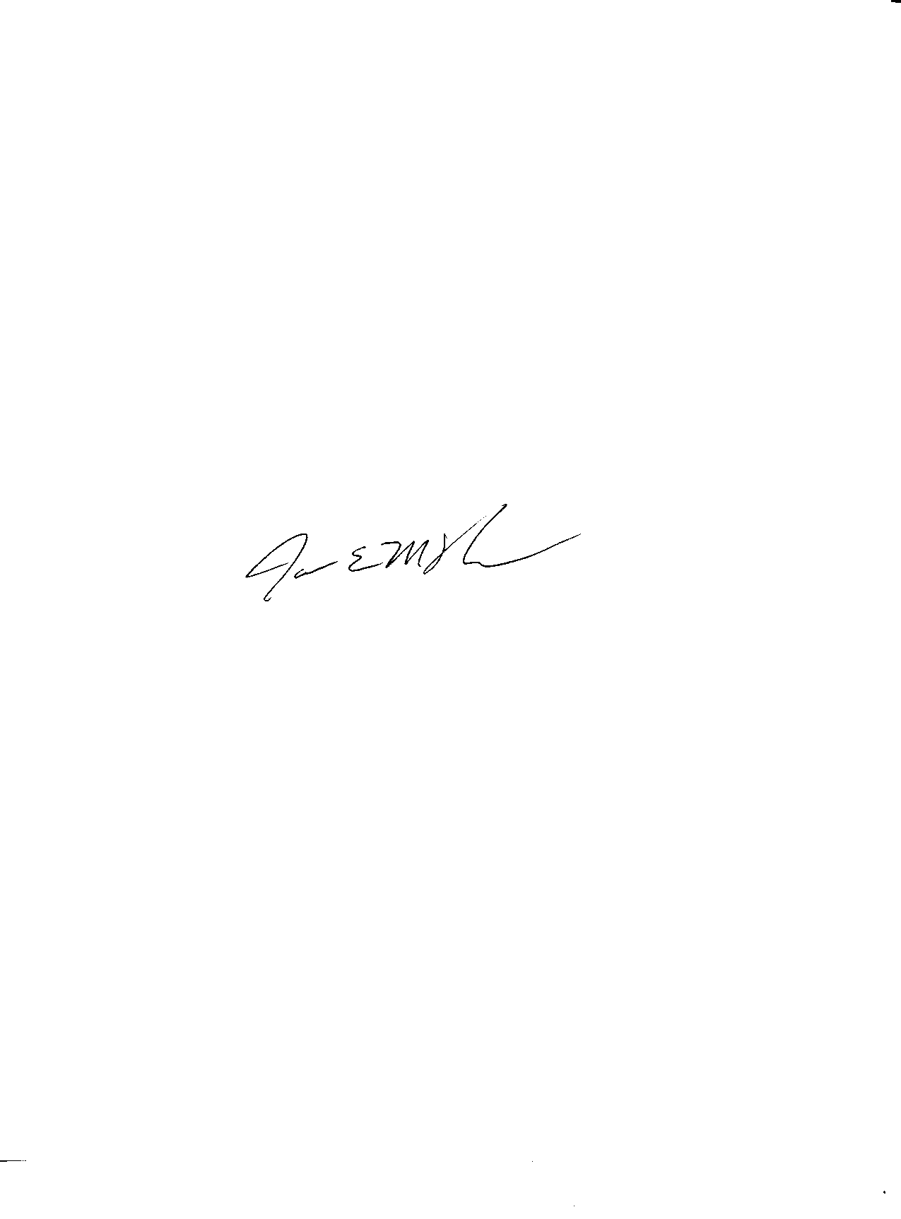
James E. McNew
Senior Vice President,
Technical & Market Services
Outdoor Power Equipment Institute
703-549-7600

Redacted ANSI B175 2-20xx Performance Test

Blower Performance

Scope
The procedures (using the “blow force method”) for measuring blower and blower-vacuum blowing performance may be found in Annex C.

Test Values
The values shall be measured and reported at the exit of the nozzle(s) supplied with the unit. The values reported shall be the maximum and average velocity in M/S (MPH) and average air volume in CMM (CFM). Values shall be rounded to the nearest whole number.

If the volume (Q) is to be included in the Operator’s Manual, it shall be the average volume based on this section. If multiple pipe configurations come standard with the unit, they shall all be measured and the results for each pipe configuration listed in the Operator’s manual.

If the max velocity (V_{p}) is to be included in the Operator’s Manual, it shall be the value based on this section. If multiple pipe configurations come standard with the unit, they shall all be measured and the results for each pipe configuration listed in the Operator’s manual.
Annex C—Blowing Performance Measurement Procedure

Note: The formulas below are included in the spreadsheet at the end of this section. The attached spreadsheet also compensates for standard atmospheric conditions.

C.1 Equipment

C.1.1 A force measuring plate consisting of aluminum shall be used. The diameter shall be diameter: 350 +/- 5 mm (13.8 +/-0.2 in). The thickness shall be sufficient to keep its weight to a minimum while retaining plate stiffness

C.1.2 A load cell or scale shall be used. The desired measurement range is 0 to 20 kg (0 to 44.1 lbs). Follow the manufacturer’s recommendation for maintenance and calibration of the device. The load cell (or scale)is used to measure the pressure of the airstreams on the force plate. This value is in kg_{f} and is known as value “F_{b}”.

Prior to each force test, measure the temperature of the air stream by placing a probe within 25.4 mm (1 in) of the exit tube.

C.3 Procedure

C.3.1 Warm-up and Operating Condition
The engine shall be tested warm and with the carburetor adjusted in accordance with the manufacturer’s recommendations. The test is run with the units throttle set to maximum (Wide Open Throttle or WOT). The unit may be run in (engine break-in) before the test.

The unit shall be evaluated with all the standard attachments included with the unit by the manufacturer. The attachments shall be mounted in accordance with the manufacturer’s instructions.

C.3.2 Equipment Setup
Mount force gauge with plate parallel to tube outlet plane at a distance of 125 +/-25 mm (4.9 +/-1 in). The tube outlet should be centered on plate centerline axis. The force gauge should be mounted onto a structure that will not influence the direction or flow of the air stream and shall be sufficiently rigid so as not to move when the blower stream is directed upon the force plate.

The tube angle to plate and centerline position may be manipulated to reach maximum stabilized reading as long as no part of tube is closer than 125 +/-25 mm (3.9 +/-1 in) to the plate.

C.4 Theory and Performance Calculations

C.4.1 Terms used
$$D$$

$D_{h}$= Hydraulic diameter (calculated effective diameter of non-circular tube outlet) (m)

$A$ = Area of tube outlet (m²)

$P$ = Perimeter of tube outlet (m)

$R_{e}$= Reynolds number of tube outlet

$ρ$ = Air density at air stream’s temperature (kg/m³) (correct for humidity)

$V_{p}$= Peak velocity (centerline velocity) (m/s)

$ν$= Dynamic viscosity of air at air stream’s temperature (N-s/m²)

$V_{\text{ave}}$= Average air velocity (m/s)

$F_{b}$= Blow force (N)

$Q$= Flow rate (m³/h)

$n$= Exponent term which is discussed in section 8.3.3 of the publication “Fundamentals of Fluid Mechanics” by Munson, Young, Okiishi, (Second Edition). $n$ is used to calculate the relationship between peak velocity and average flow velocity (power-law velocity profile).

$\frac{V_{\text{ave}}}{V_{p}}=\frac{2n^{2}}{(n+1)(2n+1)}$ as derived in Example 8.4, p.483 of Munson, Young, Okiishi

The Chart to determine $n$ is taken from Sec. 8.3.3, p. 481 of Munson, Young, Okiishi.

n shall be to three decimal places.

C.4.2 Calculation For Round Outlet Tubes

- Calculate $V_{\text{ave}}$ using $F_{b}$:

$$V_{\text{ave}}=\sqrt{\frac{F_{b}}{ρA}}$$

- Calculate Reynolds number:

$$R_{e}=\frac{{ρV}_{\text{ave}}D}{ν}$$

- Calculate $n$ as follows:

If Re is less than or equal to 267000: n=(0.70789)ln(Re)-1.0262
If Re is greater than 267000: n=(0.9263)ln(Re)-3.7575

- Calculate $V_{p}$:

$$V_{p}=\frac{V_{\text{ave}}(n+1)(2n+1)}{2n^{2}}$$

- Calculate flow rate:

$Q=\text{3600}(V_{\text{ave}})(A)$

C.4.3 For Non-circular (flared) Outlet Tubes—Must use hydraulic diameter for best approximation of tube geometry.

- Calculate $V_{\text{ave}}$ using $F_{b}$:

$$V_{\text{ave}}=\sqrt{\frac{F_{b}}{ρA}}$$

- Calculate hydraulic diameter:

$$D_{h}=\frac{4A}{P}$$

- Calculate Reynolds number:

$$R_{e}=\frac{{ρV}_{\text{ave}}D_{h}}{ν}$$

- Calculate $n$ as follows:

If Re is less than or equal to 267000: n=(0.70789)ln(Re)-1.0262
If Re is greater than 267000: n=(0.9263)ln(Re)-3.7575

- Calculate $V_{p}$:

$$V_{p}=\frac{V_{\text{ave}}(n+1)(2n+1)}{2n^{2}}$$

- Calculate flow rate:

$$Q=\text{3600}(V_{\text{ave}})(A)$$

C.5 Test Data to Be Recorded (See Figure C-1 for Sample sheet)
- Geographical location.
- Date, temperature, humidity, and barometric pressure.
- Test equipment information.
- Names of unit operators and/or technicians.
- Make, model, and serial number of the unit being tested.
- Blower attachments
- All measured values and calculations.
- Engine speeds (RPM) at which readings were taken.

Figure C-1—Sample Performance Measurement and Calculation Sheet (The below Illustration is an embedded Excel calc file)

This page intentionally left blank.

