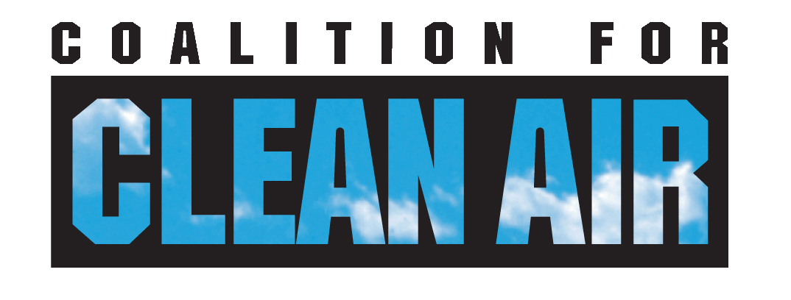

To: CARB Staff
From: Shankar Prasad, Tim Carmichael
Coalition for Clean Air
(shankar@coalitionforcleanair.org)
Cc: Economic and Technology Advancement Advisory Committee
Board Members
Re: Comments on Protecting and Benefiting Impacted Communities in
the Draft Scoping Plan
Date: August 11, 2008
Via: Electronic Submission at
http://www.arb.ca.gov/cc/scopingplan/spcomment.htm

Coalition for Clean Air (CCA) commends the staff for the comprehensive nature of the Draft Plan that recommends a broad array of GHG emission reduction measures to achieve the targets set by AB 32. Our comments here focus on two major concerns – protecting and providing benefits to the most impacted communities and quantifying the impacts.

Community Benefits
Historically, U.S. and state regulations have focused on either reducing criteria pollutants (or their precursors) and toxics to improve the air quality at a regional level or reducing the risk at the fence line from a source. The number of sources in a given area is not typically a primary consideration in the permitting process. Thus, there are many geographical areas generally referred to as “hot spots” with a high percentage of low-income and minority populations that are impacted by exposure to many chemicals from multiple nearby sources. Hence, recognizing the likelihood of increasing disproportionate and cumulative impacts in such communities as a result of GHG emission reduction efforts, AB 32 requires its regulations and compliance mechanisms:

- do not disproportionately impact low-income communities;
- consider the potential for direct, indirect and cumulative emission impacts in communities that are already impacted by air pollution;
- prevent any increase in the emissions of toxics or criteria pollutants; and
- direct public and private investment toward the most disadvantaged communities.

This language in the statute clearly indicates the need to focus on real-life conditions and consider exposure from multiple pollutants and facilities. It is also reflective of the fact that although air quality has improved over time in a regional context, all communities have not experienced the same level of improvement, as evidenced by recent risk assessments conducted by CARB. In addition, it is clear that no back sliding (no increase in pollution) should be allowed and low-income communities must not only be protected but they should benefit from the implementation of AB 32.

In its current version, the Plan does not explain how CARB plans to meet or address these requirements. In this regard CCA urges CARB staff to consider a framework that includes: a) using cumulative impacts screening to identify these communities; b) placing limitations on facilities located in these areas to participate in a trading scheme; c) dedicating a fixed percentage of revenues generated from any market-based approach to create a Community Benefits Fund; and d) requiring entities that purchase allowances or offsets to contribute to the Community Benefits Fund. The document detailing this framework is attached.

We are particularly concerned that Cal/EPA is working on a much slower time line for developing guidelines on cumulative impacts assessment than is needed. At the recent CCEEB Summer Issues Symposium OEHHA Director Joan Denton reported that a report on cumulative impacts would not be completed until the summer of 2009 and guidance to industry on how to conduct cumulative impact assessments would come a few years later. This is inconsistent with AB 32 requirements. In addition, there is an urgent need to have uniformity and consistency among the state, air districts and other local governments to ensure that communities identified as impacted by one does not get categorized differently by another. The final Scoping Plan needs to include a schedule for action on this issue to ensure that any regulation to be adopted can undergo its evaluation in this context prior to its adoption by the Board.

CCA is also concerned that failure to have a plan to meet this primary intent and requirement of the law could lead to litigation of any future regulation that gets adopted and could delay emissions reduction timeframes.

Climate Change Impacts and Co-benefits
CCA commends the efforts made to quantify co-pollutant reduction and estimated health benefits associated with co-pollutants (NOx and PM) reduction associated with 2020 GHG emission reduction targets. CCA urges CARB staff to include the estimates of potential direct health impacts of climate change in the final version of the plan.

The magnitude of impacts seen in California during summer 2006 (one of the top five hottest years on record) is shown in the following Table.

Impacts of Heat Wave During Summer of 2006
(July 15 – Aug 1)
Excess deaths from all causes | 615
Heat-related deaths (typical 10-12 deaths) | 145
Excess ER visits | 16,166
Heat-related ER visits (typical 400 visits) | 2537
Excess hospital admissions | 1182
Source: Preliminary results –
California Dept. of Public Health

Such episodes are very likely to recur and continue until global warming trend changes, which will be dependent on actions taken at the local, state, national and international levels in the near future. Thus, low-income urban communities and rural areas in the Central Valley containing higher percentage of residents of color, are at risk from adverse effects of increased temperatures and heat waves, as they lack air-conditioning, capacity to travel from impacted areas for relief as well as access to community-level programs.

CARB should include these impacts into the economic modeling because the economic benefits of GHG reductions would be significantly higher than currently projected in the Plan. In addition, it is as important to invest in adaptation programs as in emission reduction programs to help both the affected communities and the local governments cope with episodic impacts most likely to recur due to global warming. The type of programs that need to be undertaken will differ significantly depending on the geographical location and the local needs of a community.

In addition to the above concerns, CCA shares the same view as many other environmental organizations in terms of: a) increasing the target reductions from local government actions and regional GHG targets; b) taking proactive steps to promote high speed rail and reduce VMT; c) taking firm actions to ensure a 33% RPS; d) evaluation of all market mechanisms to the same extent as done for the Cap And Trade Program; and d) modifying the Cap and Trade Program Design elements of the Plan. Relative to Cap and Trade, we urge CARB to modify the major elements as follows:

- allowances should be auctioned;
- auction revenue should be used in the public interest;
- if allowed, offsets should account for no more than 10% of the reductions to be achieved, not 10% of emission allowance; and
- revenue generated should assist in emission reduction efforts and adaptation measures to most impacted communities and local governments.

