July 18, 2008

Mary Nichols, Chair
James Goldstene, Executive Director
California Air Resources Board
1001 I Street
Sacramento, CA 95814

Re: Comments on the Draft AB 32 Scoping Plan

Dear Ms. Nichols, Mr. Goldstene and members and staff of the California Air Resources Board,

Our organizations commend the California Air Resources Board (CARB) for producing the first economy-wide framework in the United States to address global warming. This plan is an important milestone and sets California on the path toward becoming a model for reducing emissions across all sectors of our state’s economy.

Global warming is one of the most serious threats to wildlife worldwide. Average temperatures have increased by about 1.5 degrees Fahrenheit (°F) worldwide over the past century. According to the Intergovernmental Panel on Climate Change, if increases exceed more than 2.7°F to 4.5°F above current temperatures, 20 percent to 30 percent of all species worldwide are likely to be at increased risk of extinction. By 2050, temperatures in California are projected to increase by 2.4°F to 3.6°F, and by 2100, the projected increase is 4.1°F to 10.4°F. Clearly, global warming will increase the stress on California’s already stressed plant and animal species. We need to address this problem comprehensively and quickly: the health of the natural systems on which our economy and way of life depend is at serious at risk.

We are pleased to see in the draft scoping plan (the Plan) that CARB has responded positively to recommendations made by our organizations. The Plan suggests a strong and cost-effective cap on greenhouse gas (GHG) emissions and a market-based program to reduce greenhouse gas emissions from major emitting sectors. We support these criteria and recommend that in the final Plan, CARB specifically include forest-based offsets in the market-based program. The inclusion of forest-based offsets coupled with a strong declining cap will foster significant GHG reductions in a cost-effective, timely and efficient manner from capped sectors. It will also secure a role for natural systems, initially through forests, as effective GHG mitigation tools, a public service (among many others) that has been historically undervalued.

Furthermore, we appreciate that the Plan acknowledges the need to provide funding to help human communities and natural systems adapt to climate change through the collection of GHG revenues and the establishment of a California Carbon Trust. We urge that the final Plan dedicate at least 20% of the available funding to plans, projects and programs that foster adaptation allowing human communities and natural systems, wildlife, plants and habitat to survive the negative impacts of global warming that will increase stress on these critical natural systems.

We also support the plan’s recommendation to establish a firm target for forest carbon statewide. The draft Plan’s proposed target of five mmtCO2e is modest and we recommend that ARB consider increasing this “floor” by re-evaluating input provided by the forest sector Climate Action Team (CAT) subgroup. In order for the state to maintain this level, policies and programs that address emissions from land conversion must be adopted. Towards that goal, we request that the final Plan clearly establish the use of CEQA as an appropriate tool to mitigate carbon emissions from forest and wildland (e.g., wetland and grassland) conversion. In addition to establishing this “no-net-loss” of forest carbon policy, we urge CARB to adopt a non-binding forest carbon restoration goal for the state and pledge to work with CARB to develop the specifics of this goal. Finally, we urge CARB to move quickly to establish scientifically derived protocols and processes to develop reduction and accounting methods for other habitats such as wetlands and grasslands.

To succeed in reducing emissions and addressing global warming, the final Plan must provide assurance that the reductions are real, measurable, and meet the other requirements of AB 32. Thus, the final Plan should specify that reductions from the forest sector be evaluated under the existing, CARB-approved, accounting methods, standards, and protocols acknowledging that CARB may adopt refinements to them over time.

As currently drafted, the role that CARB intends for the Board of Forestry and Fire Protection to play is vague. CARB should clarify that role soon to avoid confusion. In addition, the final plan should explicitly reaffirm CARB’s responsibility as the lead agency for adopting reduction measures and other policies involving all sectors, including the forest sector, and including especially, the accounting rules and responsibilities for state and project level inventories.

The impact of local and regional land use decisions on GHG emissions is significant. In this area too, adoption of revised planning processes and other measures can reduce emissions from transportation, energy, water use and waste recycling beyond the values included in the scoping plan. We urge CARB to adopt an ambitious and meaningful target for reductions from the landuse sector
A robust role for forests and other natural resource based projects is critical for the success of the Plan and the public’s acceptance of it. Recent polling information released by Next Ten underscored the importance of establishing a comprehensive role for natural resources in the state’s climate policy. Conducted last month, the poll found that
- 79 percent say that global warming is a serious threat to the economy and quality of life for California's future
- 88% strongly support protecting forests and natural areas that naturally remove global warming pollution from the air as part of the state’s plan

- 81% recognize that protecting existing forest lands was very important as an additional benefit from addressing global warming.

In conclusion, we look forward to reviewing the technical appendices to the draft Plan when they are released and may submit additional comments at that time. We commend CARB and its staff for their hard work in producing the draft AB 32 scoping Plan We urge CARB to make firm and binding commitments in the final Plan to policies that fully capitalize on the capability of forests and other natural resource-based projects to address climate change both by avoiding emissions and increasing carbon sequestration.

Sincerely,

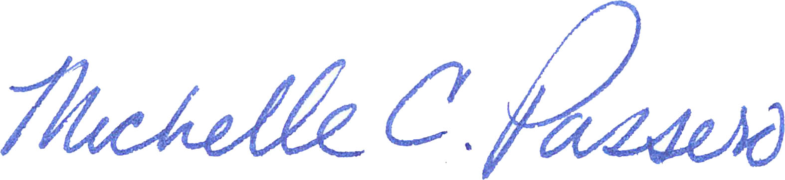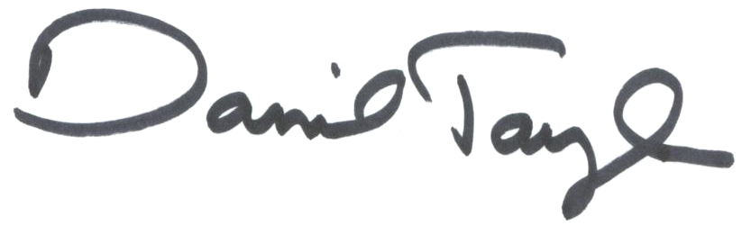

Michelle Passero Kim Delfino Dan Taylor
The Nature Conservancy Defenders of Wildlife Audubon California

