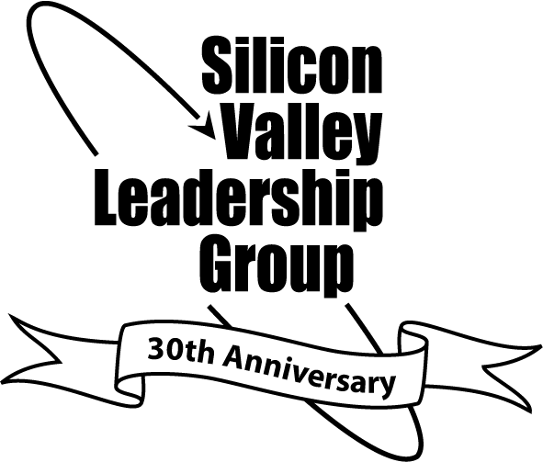

224 Airport Parkway, Suite 620

San Jose, California 95110

(408)501-7864 Fax (408)501-7861

http://www.svlg.net

CARL GUARDINO

President & CEO

Board Officers:
MICHAEL SPLINTER  Chair  Applied Materials  WILLIAM D. WATKINS  Vice Chair  Seagate Technology | watking

ROBERT SHOFFNER

Secretary/Treasurer

Citibank

WILLIAM T. COLEMAN III

Immediate Past Chair

Cassatt Corporation

AART DE GEUS

Past Chair

Synopsys

Board Members:

JOHN ADAMS

Wells Fargo Bank

JOHN AMBROSEO

Coherent, Inc.

SHELLYE ARCHAMBEAU

MetricStream, Inc.

NED BARNHOLT

KLA-Tencor

TOM BOTTORFF

Pacific Gas & Electric

MARK DEAN

IBM Corporation

RAQUEL GONZALEZ

Bank of America

JON HOAK

Hewlett-Packard Company

LEONARD KWIATKOWSKI

Lockheed Martin Space Systems

RICHARD LEVY

Varian Medical Systems

PAUL LOCATELLI, S.J.

Santa Clara University

DOUG MERRITT

SAP Labs

LEN PERHAM

Optima Corporation

KIM POLESE

SpikeSource, Inc.

WILLIAM E. RHODES III

BD Biosciences

DAVID J. SHIMMON

Celerity, Inc.

ABHI TALWALKAR

LSI Logic
DAN WARMENHOVEN | NBC 11

Network Appliance

TOM WERNER

SunPower

KENNETH WILCOX

SVB Financial Group

Working Council Chair

VICTOR ARRAÑAGA, JR.

Applied Materials

Established in 1978 by
DAVID PACKARD

July 31, 2008

Ms. Mary Nichols,
Chair, California Air Resources Board
P.O. Box 2815, Sacramento, CA 95812

RE: The Importance of Regional Partnerships to Realize California’s Climate
Change Goals

Dear Mary:

As you know, the Silicon Valley Leadership Group supported the California Global Warming Solutions Act of 2006. We did so because we believe that reducing the state’s greenhouse gas emissions and our dependence on imported fossil fuels presents an opportunity to transform our economy from one based on coal, oil, and gas to one that runs on clean renewable energy while also helping clean our air, protect our land and water and safeguard our health and welfare.

We appreciate the scope and complexity of the challenge of implementing AB 32 and we and applaud the deliberative, thorough and careful approach undertaken by the Air Resources Board in crafting the draft scoping plan. We believe we can achieve the steep reductions in global warming pollution set forth in the plan, but it will be no small task. Being the first state to enforce an economy-wide cap on greenhouse gases is a major undertaking, and all California residents and businesses have a role to play.

No one company, organization or individual’s actions alone can address the challenge of climate change. There is a profound need for coordinated action; cooperation between key public, private and other stakeholders is critical. The Leadership Group and our members are rising to this challenge by helping lead a Bay Area public-private climate change partnership, to jointly guide and develop actions that reduce greenhouse gas emissions, and increase the region’s resiliency to the impacts of climate change. Our action areas include:

- Creating a common reference standard for green building and rooftop solar;
- Incentivizing transportation mode-shifts to reduce gasoline consumption;
- Increasing the use of renewable energy;
- Reducing electrical energy usage;
- Increasing the available green workforce;
- Decreasing water consumption and increasing water recycling;
- Adopting municipal and organizational climate adaptation plans;
- Implementing a regional climate change public information campaign;
- Increasing solid waste diversion;
- Increasing the number of hybrid electric and zero emission vehicles in use

We are finalizing targets in these ten goal areas with our partners, including leading businesses, the cities of San Jose, San Francisco and Oakland, and agencies such as ABAG, MTC, BCDC, and BAAQMD.

As our regional partnership moves forward, we look forward to working with the Air Resources Board and other stakeholders to realize the most vital, effective and cost-effective emissions reductions.

Sincerely,
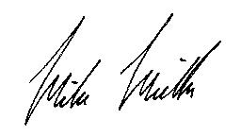
Mike Mielke
Director, Environmental Programs

