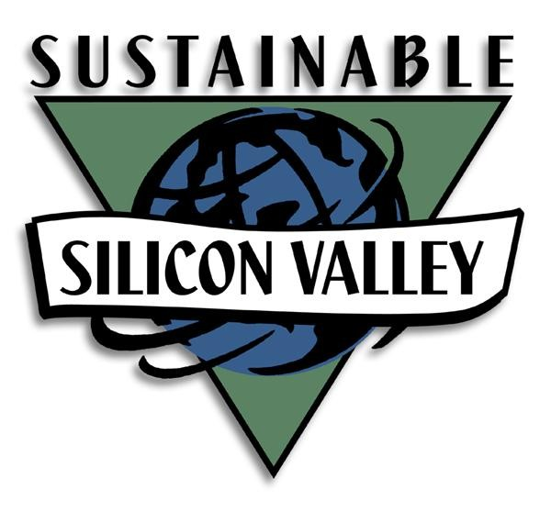

July 31, 2026

Ms. Mary Nichols
Chair, California Air Resources Board
P.O. Box 2815
Sacramento, CA 95812

Subject: Sustainable Silicon Valley Comments on AB 32 Scoping Plan

Dear Ms. Nichols:

On behalf of the Sustainable Silicon Valley (SSV) Board of Directors, I commend the Air Resources Board for the development of the AB 32 scoping plan.

Sustainable Silicon Valley is a multi-stakeholder collaborative seeking to produce significant environmental improvement and resource conservation in Silicon Valley. SSV began in 2001 as a project of the California Environmental Protection Agency, and became a 501(c)(3) corporation in 2004. SSV’s vision is a thriving Silicon Valley with a healthy environment, a vibrant economy, and a socially equitable community. SSV currently partners with almost 90 cities, companies, academic institutions and other non-profits in Silicon Valley.

SSV requests that the following comments be addressed in future revisions of the scoping plan:

Incorporate the Success of SSV and Our Regional Partners in Reducing CO₂ Emissions across the Silicon Valley Region As an Example for California.

SSV partners have reduced their carbon dioxide emissions at twice the rate of the whole Silicon Valley region. The SSV approach can be more broadly applied across California. SSV and our partners request to meet ARB staff to discuss our work in setting a regional emissions target, and SSV’s recognized success in influencing greenhouse gas reduction in the region. We would also like to offer to discuss how a regional environmental management system approach could be utilized to track progress in meeting AB 32 targets.

Elevate Priority of Vehicle Miles Travelled

The draft AB 32 Scoping Plan targets local government land use decisions for only 2 million metric tons (MMTs) of reduced greenhouse gas emissions out of the total 169 MMTs which is the estimated target for achieving the AB 32 goals for cutting California’s greenhouse gas emissions to 1990 levels by the year 2020. Since transportation is California’s single largest source of greenhouse gas emissions, and since a large part of the transportation-related carbon emissions is caused by long-distance commuting patterns based on local land use decisions, we see opportunity for greater reductions from these decisions than recognized in the draft Scoping Plan.

Rising gas prices already are causing many Californians to rethink their attitudes towards car use and the locations of their homes and jobs. The Scoping Plan could assist in reinforcing fundamental shifts in people’s thinking—as well as reduce crime, vandalism, and other social problems—by encouraging mixed-use neighborhoods near transit, building homes near job centers, and funding transit and other alternatives to individual driving.

The Scoping Plan could achieve these goals by:
- Shifting capital investment funding to local governments and regions which promote climate-friendly land use patterns
- Putting more emphasis on CO2 reductions from local land use and transportation policies which reduce unnecessary driving, car use, and gasoline consumption
- Supporting transit and other alternatives to single-passenger car use which would use existing streets and highways more efficiently for maximum individual mobility.

Partner Local Governments with Non-Profits to Plan Better Regionally

SSV recognizes the need for regional planning, and has acknowledged experience in fostering regional cooperation amongst a range of organizations including local governments. The success of local governments in reducing greenhouse gases, particularly by reducing vehicle miles travelled, will depend largely on their success in cooperating regionally. Unfortunately, local governments have not been designed or resourced to coordinate their communities to accomplish these tasks. They lack resources, staff, knowledge, experience, direction, scope, and authority. Specifically, doing what is necessary for this is outside the scope of a municipality’s governance scope of authority.

The solution to this issue is the empowerment and encouragement of local governments to partner with a range of community groups and non-profits, such as SSV, that do have the network, capabilities, and time to assist in this work without new “formal” agencies or joint powers authorities.

Reconsider the Proposed Public Goods Charge on Water

There is little explanation of how the new funding provided by the proposed Public Goods Charge on water would be used by the State. Regardless of plans for spending such funds by the State, water agencies and retailers in Silicon Valley all have successful water use efficiency programs that reduce energy use and GHG emissions; and our water community is already responding to the Governor’s Executive Order to reduce per capita water use 20 percent by 2020. So, we request that any fees that would be used to fund water use efficiency efforts to meet ARB reduction goals or local agency goals be levied and spent by such agencies rather than the State.

Direct Reduction Efforts to High End-User Water-Related Emissions.

ARB’s efforts to reduce water-related GHG emissions should focus first and foremost on reducing GHG emissions from end users, while allowing the water community to continue to implement and secure funding for their ongoing initiatives to meet water conservation and recycling targets. Approximately 80 percent of greenhouse gas emissions associated with water occurs with the end user (residential, commercial, industrial and agricultural); and it appears that the Scoping Plan has underemphasized this major source of water sector related emissions. The water community has been responsible for reduction of end user water use by modifying end user practices and behavior through their aggressive conservation programs and their efforts to change the plumbing code to require water-efficient devices. However, they are unable to enforce GHG emissions reductions relative to end user violations, manufacturer violations, or land use planning decisions.

We look forward to working with CARB to refine the Scoping Plan and to achieve its emissions reduction target for 2020. If you have any questions, please contact me.

Sincerely,
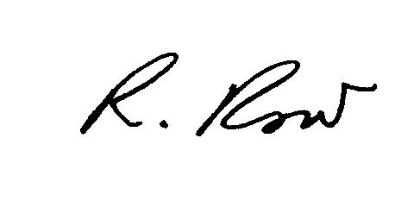

Rick Row
Executive Director
Sustainable Silicon Valley
Tel: (650) 269-1121
Email: rrow@SustainableSiliconValley.org

cc: Each Member of the California Air Resources Board

