August 7, 2008

Ms. Mary Nichols
Chair, California Air Resources Board
P.O. Box 2815
Sacramento, CA 95812

RE: Draft Climate Change Scoping Plan

Dear Ms. Nichols:

The Bay Area Council applauds the work the Air Resources Board has done to date in steering the state towards meeting the goals laid out in AB 32. We are particularly supportive of your recommendation for a comprehensive cap and trade program and we hope that business can lead in the development of innovative approaches to make this system work.

We have concerns however that that Climate Change Draft Scoping Plan does not sufficiently address one major piece of the puzzle, that being more efficient land use.

As co-signators, with the Urban Land Institute (ULI), of California 2020 Responsible Land Use: A Path to a Sustainable California by 2020, we feel strongly that if we are to meet the ambitious AB 32 greenhouse gas reduction targets, especially those set for 2050, we need to immediately begin addressing the inefficient land use patterns which have forced so many Californians into automobiles and onto our freeways. While The Draft Scoping Plan lays out a clear strategy on how to reduce the carbon impact of those drivers through cleaner fuels and better mass transit options it does little to address how we can change those transportation patterns and reduce vehicle miles travelled (VMT) through better, more efficient land use.

We have also been working with Senator Darrell Steinberg for over two years on ensuring that California 2020 principles are incorporated in SB 375 and we are very pleased that the cities, the environmental community and the home builders have now reached agreement on how to develop California in a smart and sustainable manner going forward.

We have developed a horizontal suburban state with large housing subdivisions linked by large freeways to distant job centers and services traversed by people in large SUVs. We feel that while it is important to address that large SUV and its emissions, it is equally, if not more important to address the land use patterns that are at the core of this problem. As our overall VMT grows, new technology will not be able to keep pace with the emissions produced by all those additional miles travelled. We need to get people out of their cars and if they do have to drive we need to reduce the length of those trips. This can only be achieved by developing a regional planning focus and altering our land use behavior.

A study in the Bay Area by the Metropolitan Transportation Commission found that for people who both live and work within half a mile of a rail or ferry stop, 42 percent of them commute by transit. For those who neither work nor live within such proximity, the number falls to 4 percent. Elsewhere, individuals living in higher-density neighborhoods that include convenient access to transit, as well as pedestrian and bicycle-friendly features, reduce their driving by 15 to 50 percent.

We need to incentivize and facilitate Transit Oriented Development, as well as remove barriers and impediments to urban infill development where homes are built close to retail, services and jobs. We need to develop a plan that will reduce VMT by building dense multi-family housing closer to services and jobs, and we need to focus on getting people out of cars.

We would like to suggest that the Bay Area region be put forward for a regional pilot program on how best to reduce VMT through better land use and more efficient transit alternatives. The Bay Area is the ideal place for such a program since we have an abundance of urban infill and TOD opportunities and the political and popular will is here to see the necessary changes made in order to reduce greenhouse gas emissions.

It can take decades to effect meaningful land use changes therefore we encourage you to adopt the policies laid out in California 2020 and SB 375 and address this issue as soon as possible. We look forward to working with you to make California a cleaner healthier place for all its citizens.

Sincerely,

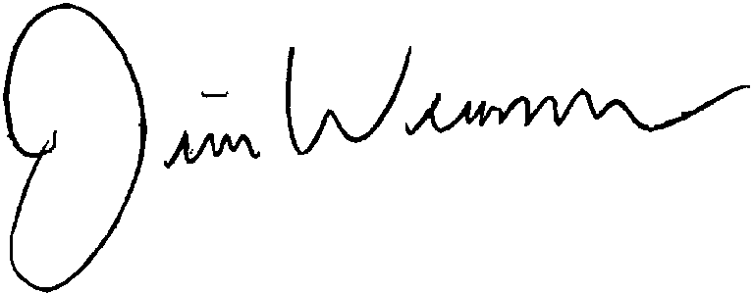

Jim Wunderman
President & CEO
Bay Area Council

Cc: Members, California Air Resources Board
Metropolitan transportation Commission
Association of Bay Area Governments
Bay Conservation and Development Commission

