August 14, 2008

California Air Resources Board
1001 “I” Street
Sacramento, CA 95812

Re: AB 32 Draft Scoping Plan Inclusion of Community Empowerment Fund

Dear Chairman Nichols and Members of the California Air Resources Board:

We would like to congratulate the Air Resources Board (ARB) for taking a huge step in the implementation of AB 32 with the release of its draft scoping plan, the Nation’s first comprehensive state plan to address global warming emissions. In designing the scoping plan, the Air Resources Board is charting the course towards a sustainable future with cleaner air, green jobs and increased economic opportunities for all Californians.
We are very encouraged by the ARB’s efforts through the draft scoping plan to implement the community benefits section of AB 32 (HSC §38565), which directs ARB to ensure that GHG reduction programs direct public and private investment toward the most disadvantaged communities in California. With leadership from Global Green USA, this section, also know as the Community Empowerment Amendment (CEA), was included to ensure that a significant amount of revenue generated by AB 32 would be directed toward “the most disadvantaged communities in the State.”
We agree with the Scoping Plan’s observation that many of the potential uses of revenue generated by a carbon fee or auction would help ARB implement this fundamental component of AB 32. The ARB’s final scoping plan in October should set forth a more detailed and concrete plan for ways to fully implement the CEA. In addition, it should require polluters to pay for their pollution, and direct the resulting revenues into GHG reductions in disadvantaged communities. We urge you to ensure that a significant percentage of the carbon fee or auction revenue will be focused on zero-energy and green buildings in disadvantaged communities.
Global Green USA is committed to serve as consulting stakeholders in the development of this program through its participation in the ad hoc 38565 Steering Committee, along with members from the Environmental Justice Advisory Committee. In order to democratize this effort, we also strongly encourage CARB to solicit input from a broad list of stakeholders including grassroots community-based organizations, advocates from communities historically overburdened by poverty and poor air quality, affordable housing associations, as well as community-based institutions such as churches, community centers, etc.
We look forward to working with you on the development of the final scoping plan as it pertains to the implementation of the CEA. California truly must lead the way for the rest of the nation on this important issue.

Sincerely,
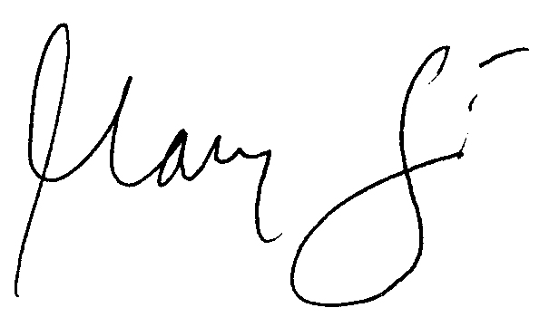

Mary Luevano

