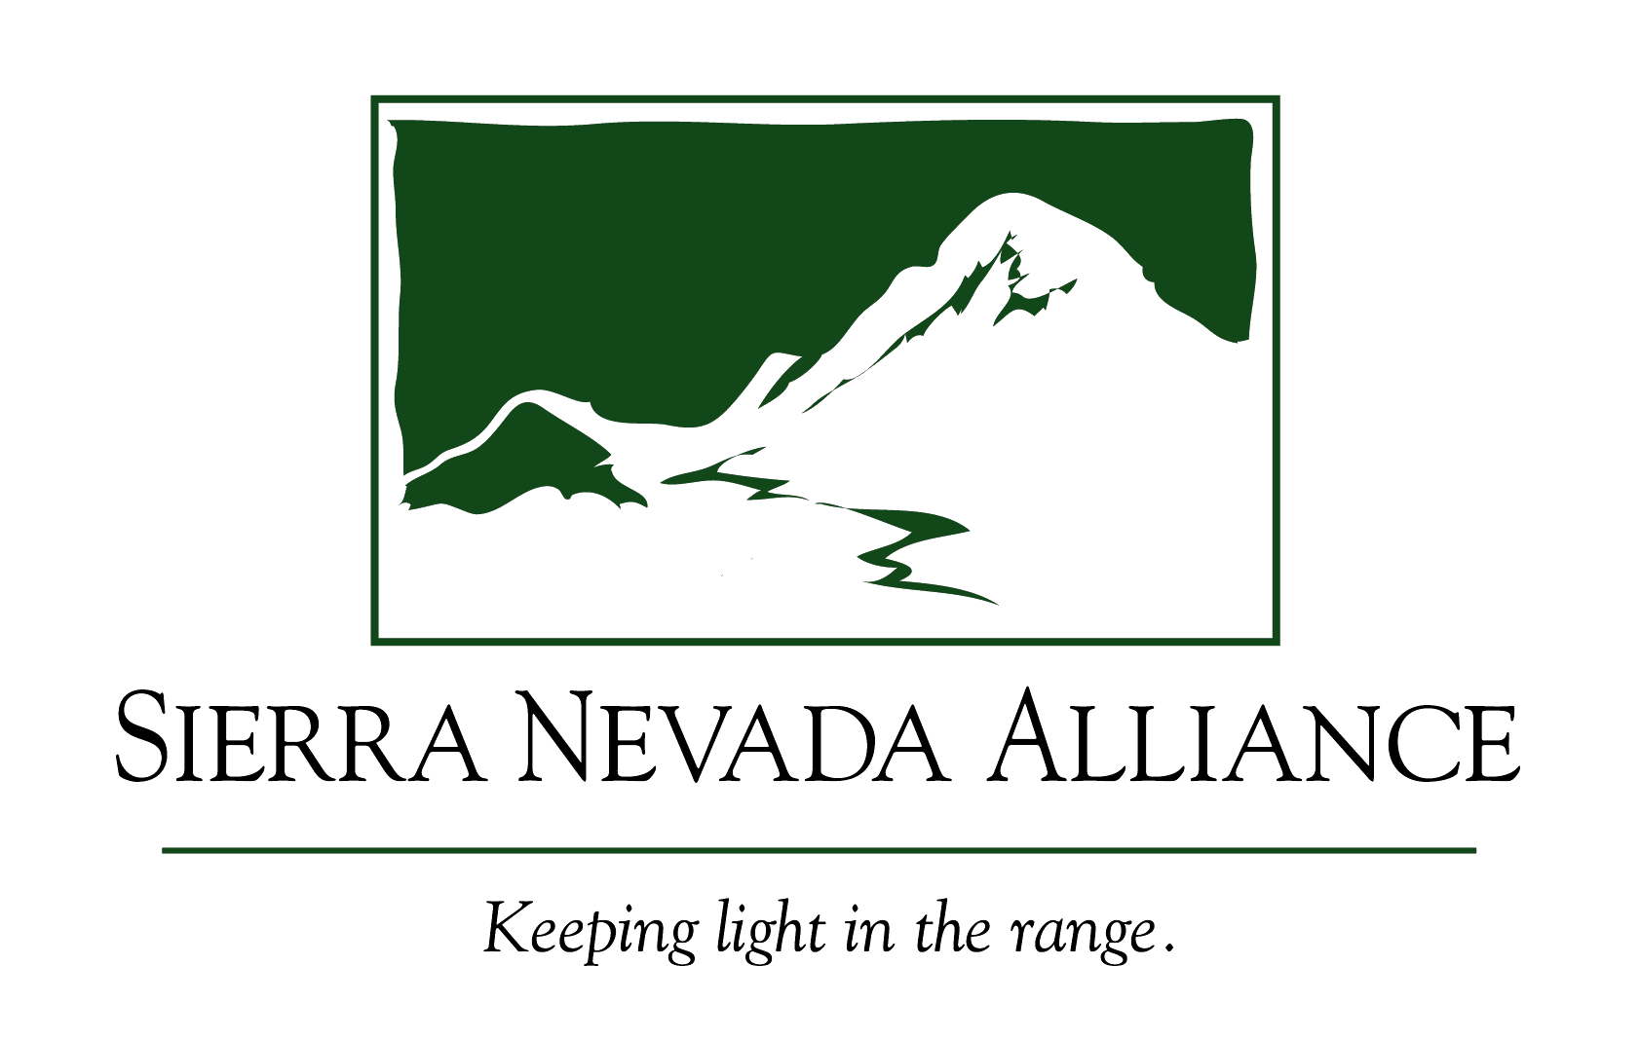

August 13, 2008

Chairman Mary Nichols
California Air Resources Board (CARB)
1001 "I" Street
P.O. Box 2815
Sacramento, CA 95812

Re: Sierra Nevada Alliance comments on the AB 32 Draft Scoping Plan

Dear Chairman Nichols, Board Members and Staff:
The Sierra Nevada Alliance (Alliance) appreciates the opportunity to submit comments on the California Air Resources Board’s (CARB) Draft AB 32 Scoping Plan, which should reduce greenhouse gas emissions in the State of California to 1990 levels by the year 2020, an achievement critical to creating a sustainable future for California.
Since 1993 the Sierra Nevada Alliance has worked to protect and restore the natural environment of the Sierra Nevada for future generations while promoting healthy and sustainable communities. The Sierra Nevada Alliance builds the capacity of a network of over 95 conservation groups and leads regional efforts to protect Sierra lands, water, wildlife and rural communities. We have three priority campaigns that address land use, water issues, and climate change.
The Sierra Nevada Alliance has five general comments on the AB 32 Draft Scoping Plan related to establishing regional targets; targeting land use; dealing with forestry, fire and fuel load reduction; addressing climate change adaptation while taking up water efficiency; and prioritizing public outreach and education in implementation of the plan.
Include the Sierra Nevada in the Plan and in Setting the Regional Planning Framework
Our priority recommendation is that the Sierra Nevada region be included in the Plan and in any Regional Planning Framework. Any vehicles for developing regional targets for reducing GHG emissions should include the Sierra Nevada region. It is unclear in the scoping plan whether regional targets or regional frameworks would be solely for land use or would be a mechanism to address other measures reducing greenhouse gases. However, whenever you use a regional approach, it will be very important to include the Sierra Nevada.
The Sierra Nevada is the third fastest growing region of the state of California. We supply over 65% of the state’s developed water. Our region houses half the animal and plant life of the state. Millions of people visit the Sierra Nevada every year.
Currently when referencing a regional approach you propose to use “major urban areas” which implies Metropolitan Planning Organizations (MPOs) . This approach would focus all implementation of land use policies on the four major urban areas of Los Angeles, San Diego, the Bay Area and Sacramento. Relying exclusively on MPOs to reduce land use-related emissions would greatly hinder the state’s ability to achieve the greenhouse gas emission reduction goals. Only 2 of the 22 counties in the Sierra Nevada are part of an MPO. The Sierra will be almost completely left out if this is the only framework for addressing land use-related GHG emissions in California.
Post Office Box 7989, South Lake Tahoe, California 96158

Phone: 530.542.4546 Fax: 530.542.4570 www.sierranevadaalliance.org
We support the concept of regional planning, and therefore we strongly encourage CARB to develop a policy for regional planning outside of MPOs. The State Water Plan created a special overlay for mountain counties in the past, recognizing the importance of the region. We would not recommend adopting this exact state water plan mountain county region because it is too limited for the entire Sierra, but this overlay does provide an example of a state plan working to include the region. The Regional Water Quality Control Boards have defined hydrologic regions that include all parts of the Sierra Nevada. The new Sierra Nevada Conservancy established in state legislation recognizes a specific geographic boundary, and subregional boundaries, for the Sierra Nevada. We highly recommend that CARB create a unique mechanism for geographic implementation of AB 32 in the Sierra Nevada or utilize one of these other units to ensure the Sierra Nevada is included.
Include a Larger Target and More Robust Suite of Enforceable Policy Mechanisms to Reduce Greenhouse Emissions through Improved Land Use and Transportation Policies
Improving land use planning is an important part of the Alliance’s mission. The population of some counties in the Central Sierra is expected to increase by 40 to 84% over 2000 levels by 2020. If current trends continue, much of this new population will be accommodated by low density residential development, a dominant development pattern throughout the region that consumes valuable habitat, working landscapes, watershed infrastructure, and increases per capita vehicle miles traveled. Though representing only a small part of the total population in California, the Sierra Nevada is the third fastest growing region in the state, and provides more than 65% of the state’s drinking water supply, including the majority of the water supply for the urban centers of California.
Land use and city and county general plan decisions should be elevated to a central focus of the Plan. The Alliance supports efforts to make sure the Scoping Plan for AB 32 includes a better framework for land use and transportation, and believes the 2 million metric target set for land use is far too low to effectively reduce carbon emissions associated with vehicle miles traveled. The “Climate Action Team Proposed Early Actions to Mitigate Climate Change in California, Draft for Public Review,” allotted 18 MMT by 2020 to “regional transportation/smart growth land use measures.” Surely the draft Scoping Plan can match this target.
As steps are taken to revise the scoping plan to reduce carbon emissions associated with commutes, we encourage CARB to ensure the creation of more walkable communities, and to prioritize funding for public transportation. The Alliance requests that the revised scoping plan:
- Include policy options to reduce vehicle miles traveled in rural areas of California, including the Sierra Nevada. While metropolitan regions contribute the majority of GHG emissions, a VMT reduction strategy that excludes rural counties will export growth pressures to those counties. We encourage CARB to expand the regional planning framework to include rural counties.
- Support the adoption of a statewide Indirect Source Rule for carbon emissions that would require development proposals that increase carbon emissions to mitigate those emissions through, for instance, site design changes or a mitigation fee to reduce emissions offsite.
- Assign value to natural landscapes that sequester carbon and ensure cities, counties and regions adopt land use plans that conserve such landscape.
Address Wildfire and Land Use by Reducing Sprawl in High Fire Areas
Also important to consider are the implications land use planning has for wildfire hazard. Evidence suggests that residential and commercial structures in the wildland urban interface exacerbate the likelihood of wildfire. CalFire data shows that, between 2000 and 2005, the majority of fires within CalFire’s jurisdiction were caused by humans. Equipment, vehicles and debris burning were among the largest ignition-source culprits. Wildfires can be a major source of carbon emissions and particulate matter during the summer months throughout the state. In the Sierra 94% of all new projected development is expected to take place in areas of very high or extreme wildfire hazard.
Considering the opportunities AB32 provides to rural counties to improve land use planning not only can further reduce carbon emissions but also would serve as a valuable means for protecting working landscapes and local food sources, and preserving watershed infrastructure. Watershed protection will become an issue of greater importance as global warming begins to affect the snow storage capacity provided by the mountains of the High Sierra. AB32 is an opportunity to encourage better planning throughout the state, including, if implemented carefully, better planning for the watersheds of the Sierra Nevada that are essential to the health and security of our water supply.
Dedicate Water Saved from Water Efficiency to help with Climate Adaptation Strategies
The Sierra Nevada Alliance applauds the Scoping Plan's promotion of water efficiency as a means to save energy. Much more detail on how water efficiency will be implemented is needed. We encourage CARB to note, however, that these water savings should not be used to support new growth and expanded development, but to support existing development and agriculture in times of drought and to be allocated back to the environment for in-stream flows. In the past, water savings have been used to support new growth and development, instead of being returned as in-stream flows for habitat needs or saved for existing development and agriculture to create a buffer in times of drought. If water efficiency continues along this “Save it to grow” model, water savings will not reduce carbon emissions.
However, if the saved water was allocated to existing communities for times of drought, and/or allocated for in stream flows to reduce the stress to aquatic habitat, then these water savings would lead to a reduction in greenhouse gases overall.
All Sierra Nevada streams and rivers have been impacted over the past 150 years through a series of human development. Every Sierra river and stream is impaired from water diversions and dams except one. To help aquatic systems adjust to increasing temperatures, changes in hydrology, and invasive species, more water is needed in stream to reduce climate stress for species to survive and flourish. Water efficiencies to save energy can be coupled with climate adaptation strategies if the saved water was specified to stay in-stream.
Ensure Sustainable Forests and Fuel Load Reduction Efforts Address Adaptation

We commend CARB for acknowledging the need to maintain current carbon stocks in forests. We encourage you to develop a sophisticated approach to sustaining forests and conducting fuel load reduction to address catastrophic fire. This approach is more than locking up forests in their current condition (overstocked and lacking naturally-occurring fire regimes to maintain their health) – and more than taking out trees to reduce fuel load, irrespective of tree diameter and greater ecological functions.

The Plan should recognize that fire is a natural and necessary part of California’s environment and will be an important part of how our natural systems adapt to a changing climate. Suppressing all natural fire to achieve greenhouse gas emissions is not an effective tool for our future. Our forests need fire to be healthy. We encourage the state to focus fuels reduction efforts (and other proactive fire planning activities) on protecting communities from fire.

We encourage you to work with Sierra Forest Legacy and other Sierra conservation groups with a rich history in forest management to meet carbon sequestration goals while meeting climate adaptation goals to help forests and wildlife transition in a changing climate.
Address Carbon Sinks Beyond Pine Forests
We also encourage CARB to address other carbon sinks beyond pine trees. This includes oak woodlands, grasslands, soil, wetlands and other vegetation. To focus simply on forests and not address carbon sequestration through these other habitats and vegetation misses an important part of the carbon cycle. The California Oak Foundation is a great resource on oak sequestration.
We recommend that CARB and the Department of Conservation create a statewide program to inventory and assess the carbon sequestration and storage of natural and working landscapes across the state, and develop protocols for measuring carbon sequestration and stocks.
Improve and Prioritize Public Education and Outreach to Implement the Climate Change Plan.
In the Sierra Nevada, we have had the opportunity to watch the Tahoe Regional Planning Agency work to implement many effective and cutting edge new programs and regulations. While the technical on-the- ground programs and regulations have been well done, they have done a poor job of public education and outreach in their implementation. Consequently, the many excellent new programs and regulations are misunderstood, resented and even hated. This has created a significant backlash to efforts to set a new course for Tahoe. Public opposition has grown significant and is slowly turning back and undoing the steps forward TRPA has made.
We encourage the CARB to learn from this lesson and others like it. The Draft AB 32 Scoping Plan is very ambitious and exciting for the new course this sets for California and the world. The only way to ensure there is not a public backlash to voluntary, regulatory, and information efforts is for there to be a very robust and high priority public education and outreach campaign to accompany every element of the plan. Do not underestimate the importance of having strong public understanding and support for each element and activity. Please ensure adequate public outreach planning and implementation are included in this plan and subsequent budgets fully fund outreach to implement this plan.
Summary

Thank you for considering our comments. We are very excited about the opportunities to shape a better future in the face of this climate change crisis. We believe your plan is a wonderful step forward. We hope you will work with the Sierra Nevada Alliance and all our partners in the region to ensure our region are included in moving this plan forward. The Sierra Nevada is an incredibly important region of California. Our lands provide clean water, prime recreation, incredibly diverse habitat, and amazing inspiration to all of California. We are also a vibrant and historically-wealthy, rural region of California with wonderful local communities. We have much to offer in helping this plan move forward and we hope you will do your best to incorporate our region into developing and implementing the plan to ensure it protects and restore the Sierra for all Californians.

We look forward to your reply and to seeing the subsequent version of the scoping plan.

Sincerely,

Joan Clayburgh
Executive Director

