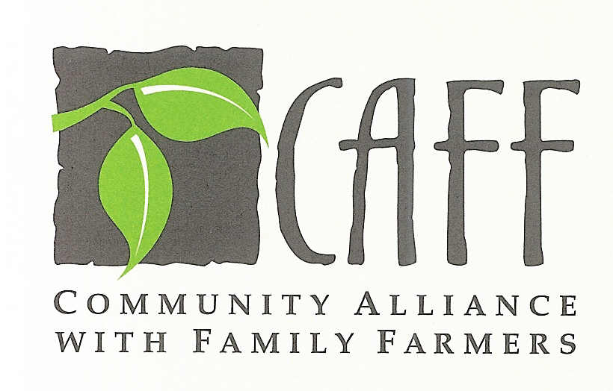

July 31, 2008

Ms. Mary Nichols
Chair, California Air Resources Board
1001 I Street
P.O. Box 2817
Sacramento, CA 95812

RE: Comments on AB 32 Scoping Plan

Dear Chairwoman Nichols:

The Community Alliance with Family Farmers (CAFF) is a statewide organization of farmers and non-farm citizens who support policies to enhance the long-term sustainability of California agriculture. CAFF works on the ground with farmers to adopt environmentally-friendly and sustainable farming practices and with private and institutional buyers to promote strong local farm economies through the purchase of fresh and locally grown farm products. We are pleased to submit the following comments to the Air Resources Board regarding the AB 32 Scoping Plan, including online submissions under both the Agriculture and Land Use sections.

CAFF’s work at both the production and market ends of California’s food system has given us ample opportunities to observe the ways in which California agriculture, when viewed comprehensively, can help reduce the state’s greenhouse gas emissions. For that reason we were disappointed at what was not included in the Scoping Plan sections on Agriculture and Land Use, especially since we and other stakeholders made similar points through the Land Use Committee of the Climate Action Team (LUSCAT) about the importance of various land use measures that could reduce GHG emissions from agriculture and simultaneously improve the long-term sustainability of California agriculture.

And we were particularly disappointed to see that the Scoping Plan reduced the targeted reduction in GHG emissions from land use measures from 9 MMT, as recommended by the Climate Action Team, to only 2 MMT. We do not understand the logic of this reduction but note with great concern that if the 2 MMT figure stands, it will fatally undermine serious efforts at land use reforms including protection of farmland.

We urge the Air Resources Board to examine closely the opportunities for GHG reductions from the following activities and to incorporate measures into the Scoping Plan that will exploit these opportunities:

- Reduce food miles by promoting local farm markets
- Encourage land use planning and development that protects farmland
- Encourage organic and other sustainable farming practices that reduce GHG emissions from fertilizers and pesticides

July 31, 2008
Page 2

1) Reduce food miles by promoting local farm markets

Just as the ARB is appropriately considering policies and measures to reduce “vehicle miles traveled,” it should examine opportunities to reduce “food miles,” or the distance needed to transport foods consumed in California. California, of course, is a major exporter of dozens of specialty crops to worldwide markets, and we see no reason that will not continue to be the case. But just as significant reductions in VMT can be gained without draconian changes in development patterns, we believe significant reductions in food miles can be achieved in California by promoting local and regional markets as vigorously as the state today promotes international markets for its farm produce.

AB 32 will force California to focus assiduously on improving its jobs-housing balance, in order to reduce commute VMT and thereby reduce not only GHG emissions, but also emissions of criteria air pollutants, traffic congestion, fuel costs, and the loss of productive time. For all the same reasons, the ARB should pay attention to reducing food miles. Currently, U.S. food travels on average 1,500 miles to reach our plate,¹ and much of that food is flown and shipped in and out of California. According to the Worldwatch Institute, the petroleum required to get a typical supermarket meal to the retail market is up to 17 times greater than the fuel needed for a meal from local sources.²

California, arguably the most diverse and vibrant agricultural producer in the world, imports 40 percent of the food it consumes. According to a Natural Resources Defense Council study, these imports generate 250,000 tons of GHG emissions just from port traffic.³ If ever there was a state or country that had the wherewithal to reduce its GHG emissions by increasing consumption of its own locally- and regionally-grown food, it is California. And the economic ripple effects would be positive as well. According to the state’s Buy California program, a 10 percent increase in purchases of California-grown foods would generate more than $800 million in additional revenue to California farms, generate almost 3,500 additional jobs and increase state and local tax revenues by almost $200 million annually.⁴ Reducing food miles is another example of how GHG emission reduction is good for the economy.

We urge the ARB to consider the following measures to reduce GHG emissions by reducing food miles:

A) Develop a food miles calculator that can be used by local and state institutions, private distributors and retailers, and the public to measure the food miles of their purchases. The calculator should incorporate, to the extent feasible, life-cycle costs of the food under consideration, including production inputs and the means of its transport, since different transportation modes for food have quite different GHG impacts.

B) Develop and implement a methodology to track food miles at the distribution and retail level. Many produce distributors are in the process of developing source-identification tracking protocols as a food safety measure; this information may provide an opportunity to document food miles as well. In the U.K. consumer demand motivated supermarkets to track and monitor the number of local product lines they carried, which then led the government to work with the largest supermarkets to carry more local product lines. The U.K. now has a national goal of reducing the environmental and social impacts of food miles by 20% by 2012. CAFF is currently involved in developing a voluntary tracking protocol for local food labeling with California-based distributors, and would be happy to partner with state agencies on the lessons it has learned.

2) Encourage land use planning and development that protects farmland

Changes in land use planning and development are some of the most difficult but far-reaching measures that state and local governments can take to reduce GHG emissions. While attention is usually focused
July 31, 2008
Page 3

on changes to urban development, such as infill and smart growth, the Scoping Plan (as well as pending legislation, SB 375) recognizes that development patterns must be changed on a regional level to reduce sprawl growth on the urban fringe. The essential corollary to policies that encourage denser urban development are policies that discourage the sprawl development of lands on the urban fringe.

One of the key goals of these policies should be to create incentives against the conversion of farmland to residential development. Currently, all the financial signals encourage farmland conversion, because the market value of land for residential development exceeds its value as farmland. But AB 32 creates an opportunity – we believe an imperative – to reconfigure the valuation of urban fringe lands as farmland versus residential development, by taking into account the value of GHG emission reductions achieved by preventing sprawl development. As a first step, we hope the ARB will develop a set of metrics to monitor the carbon impact from the transition of agricultural land to low-density housing, to ensure that future policy is scientifically informed by the impact of farmland conversion.

If the ARB persists, however, in its unreasonably low target of only 2 MMT GHG reduction from the land use/transportation sector, we fear it will not only fatally undermine significant opportunities for GHG reduction but also will send a signal that California’s longstanding land use policies that encourage sprawl development and farmland conversion will continue unabated. With a more aggressive but still achievable target, California could pursue policies to require mitigations for farmland development, using a mitigation offset ratio that recognizes the GHG reduction benefit of preventing sprawl development and concurrently retaining opportunities for “low food mile” local agricultural markets. We also urge the ARB and the Legislature to pursue opportunities to substantially increase the ability to place farmland into permanent agricultural easement, thereby permanently removing development pressures that undermine regional planning to reduce GHG emissions.

3) Encourage organic and other sustainable farming practices that reduce GHG emissions from fertilizers and pesticides

The Scoping Plan identifies N2O emissions from nitrogen fertilizers as a significant source of GHG emissions in the agricultural sector. Indeed, according to a UC Davis literature review on energy use and GHG emissions in the food system, N2O has 310 times the global warming potential of CO2, and the manufacture of synthetic fertilizers and pesticides accounts for almost 40 percent of all energy used in U.S. agriculture.⁵ In some conventional production systems, total N2O emissions, largely from synthetic fertilizer, exceeds the total CO2 emissions attributable to fossil fuel use.⁶ We therefore applaud the ARB’s two-phased research to learn more about the variables affecting N2O emissions from fertilizers and to seek opportunities to reduce emissions.

But we urge the ARB to broaden its research to include consideration of the GHG impacts of conventional farming systems that rely on synthetic fertilizers and pesticides compared to farming systems that rely on organic and other sustainable farming practices. There is a growing body of research data on comparative outcomes from these systems. A 2002 study for the U.N. Food and Agriculture Organization (FAO) found that carbon emissions from organically-grown land were 48-66 percent lower than from conventional systems, owing mainly to a much lower use of fossil fuel inputs.⁷ While all plants and soils serve as a “sink” for atmospheric carbon, long-term monitoring (since 1981) by the Rodale Institute of conventional and organic systems for soil carbon and nitrogen found that soil carbon increased in organic systems by 15 to 28 percent.⁸ One recent paper concludes that “Organic, sustainable agriculture that localizes food systems has the potential to mitigate nearly thirty percent of global greenhouse gas emissions and save one-sixth of global energy use.”⁹

July 31, 2008
Page 4

Many existing certification schemes in the U.S. and abroad are already monitoring and verifying the reduced use of GHG-intensive products – such as organic certification – and could be used to also verify GHG conservation to provide carbon credits to farmers. With a documented interest from the ARB, more research on GHG emissions from organic and conventional systems is likely to emerge. We urge the ARB to pursue such research.

We also hope the ARB will work with the Department of Conservation, the University of California and non-profit organizations like CAFF and the Organic Farming Research Foundation to develop metrics to document real, verifiable and non-additional emission reductions from sustainable farming practices. Much of the baseline data are already established in the existing Cost of Production studies developed by California’s Agricultural Extension, which list the standard use of fertilizer, pesticide and energy use.

Even with the current price premium on organic food, the market fails to incorporate significant environmental and public health benefits from organic and sustainable farming practices. As a result, non-organic farmland comprises around 95% of America’s agricultural land. Carbon credits for documented GHG emission reductions from organic and other sustainable farming practices could be a strong economic incentive to adopt these low-GHG practices.

CAFF appreciates the opportunity to offer these comments and looks forward to working with the ARB on ways to reduce GHG emissions and enhance the sustainability of California agriculture.

Sincerely,

David Runsten
Executive Director

P.O. Box 363
Davis, CA 95617-0363
530-756-8518 Phone
530-756-7857 Fax
caff@caff.org E-mail
www.caff.org Website

____________________
1. Pirog, R., and A. Benjamin. 2003. Checking the food odometer: Comparing food miles for local versus conventional produce sales to Iowa institutions. Ames, Iowa: Leopold Center for Sustainable Agriculture, Iowa State University.
2. Hal Walweil, "Home Grown: The Case for Local Food In A Global Food Market" 2002, Worldwatch Institute.
3. NRDC Policy Fact Sheet, "Food Miles: How far your food travels has serious consequences on your health", Page 2, NRDC, 2007.
4. Tootelian, Dennis H (2003), The Economic impact of shifts in consumer purchasing patterns to more California grown agricultural commodities. Available from the Buy California Initiative, CDFA.
5. Heller, M.C. and G.A. Keoleian. 2000. Life Cycle Based Sustainability Indicators for Assessment of the U.S. Food System. Ann Arbor, MI: University of Michigan, Center for Sustainable Systems.
6. Cederberg, C. and B. Mattsson. 2000. “Life cycle assessment of milk production – a comparison of conventional and organic farming.” Journal of Cleaner Production 8: 49-60.
7. El-Hage Scialabba, N. and C. Hattam (eds.). 2002. Organic Agriculture, Environment, and Food Security. Rome: UN Food and Agriculture Organization (Environment and Natural Resources Service, Sustainable Development Department).
8. Organic Consumers Association, “Organic Farming Can Help Reverse Global Warming,” October 10, 2003. Online: http://www.organicconsumers.org/organic/ globalwarming101003.cfm
9. Mitigating Climate Change through Organic Agriculture and Localized Food Systems, Dr. Mae-Wan Ho and Lim Li Ching, Institute for Science and Society, January 31, 2008 www.i-sis.org.uk/mitigatingClimateChange.php.

