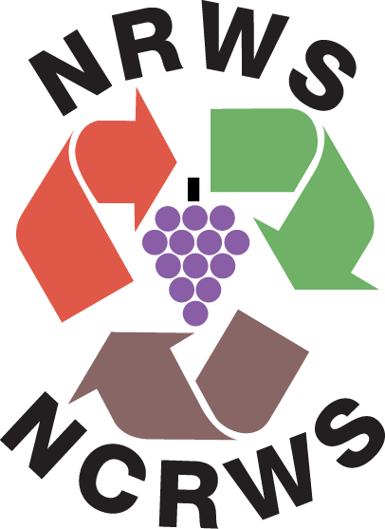

July 18, 2008

Mary Nichols, Chair
California Air Resources Board
1001 "I" Street
P.O. Box 2815
Sacramento, CA 95812

RE: California Air Resources Board's DRAFT Scoping Plan as it pertains to the recycling and waste management sector.

We, Napa Recycling & Waste Services/Napa County Recycling & Waste Services, write to you as an active member of the California Resource Recovery Association (CRRA), a statewide non-profit trade group. CRRA’s more than 550 members represent all aspects of California’s reduce-reuse-recycle-compost economy.
In 2007, nearly 100,000 tons of materials were recycled or composted at the Napa Recycling & Composting Facility. By keeping these valuable resources out of the landfill, we decreased carbon dioxide emissions by 97,366 metric tons and used 562,393 million fewer BTUs of energy. To put it in perspective, this is enough energy to power all the houses in Napa for one month! Additionally, these savings are the equivalent of taking 21,075 passenger cars off the road and conserving almost 4½ million gallons of gasoline, helping to fight climate change and reduce our dependency on foreign oil. This information has been determined using US EPA's Waste Reduction Model (WARM).
As these impressive numbers show, recycling and composting are major tools in the fight against global warming. Napa Recycling is therefore very disappointed that missing from CARB's draft Scoping Plan (http://www.arb.ca.gov/cc/scopingplan/document/draftscopingplan.pdf) are any of the following Zero Waste recommendations from Section 4. IV. (Waste Reduction, Recycling and Resource Management) of the CARB Economic and Technology Advancement Advisory Committee (ETAAC) report (http://www.arb.ca.gov/cc/etaac/ETAACFinalReport2-11-08.pdf):

J. Develop Suite of Emission Reduction Protocols for Recycling
K. Increase Commercial-Sector Recycling
L. Remove Barriers to Composting
M. Phase Out Diversion Credit for Green Waste Alternative Daily Cover Credit
N. Reduce Agricultural Emissions through Composting

In fact, the only draft Scoping Plan preliminary recommendation related to Recycling and Waste is "RW-1 Landfill Methane Control" which is presented in Table 19 on pg. 35 of the draft Plan (http://www.arb.ca.gov/cc/scopingplan/document/draftscopingplan.pdf). This lone recommendation represents a narrow-minded strategy to mitigate the worst climate impacts of wasting AFTER failing to reduce, reuse, recycle, and compost.

IF California's commonly recyclable and compostable materials that are currently disposed as mixed waste were INSTEAD recycled and composted, THEN the GHG emission reduction would be over 25 million tons CO2 equivalence, based on WARM and waste characterization data published by the California Integrated Waste Management Board (CIWMB) and verified by US EPA Region 9 staff.

The prioritized ordering of the waste reduction hierarchy to optimize resource conservation by reusing materials and repairing, refurbishing, and rehabilitating existing products and buildings to retain their form and function (and thus embodied energy) holds the potential for:
- substantially greater GHG reductions than recycling and composting alone; and
- creating ‘green collar’ jobs producing value-added contributions to the state’s economy.

These above bullet-points are explained and documented further in the recently-released report Stop Trashing the Climate: http://www.stoptrashingtheclimate.org.
Zero Waste (i.e., reduce-reuse-recycle-compost) is a significant climate protection strategy which offers tens of millions of tons of CO2 equivalence GHG emissions reductions annually for California at low cost (compared to other options) using existing, proven, environmentally sound methods.
CIWMB’s Strategic Directives were adopted as “the most effective and efficient means to create a zero waste California.” The Directives (http://www.ciwmb.ca.gov/BoardInfo/StrategicPlan/) include specific steps to minimize waste (SD 3), move toward producer responsibility (SD 5) and support market development (SD 6). Inexplicably, none of CIWMB’s Strategic Directives are part of the draft Scoping Plan.
Thus, it is difficult to understand why CARB failed to include in the draft Scoping Plan any of the ETAAC report's Waste Reduction, Recycling and Resource Management recommendations. It is particularly difficult to understand this given that the governor’s Climate Action Team has already identified Zero Waste/High Recycling Programs as a "high-confidence" strategy with significant GHG reduction potential of 10 million tons CO2 equivalent by 2020 (see: http://climatechange.ca.gov/publications/factsheets/2005-06_GHG_STRATEGIES_FS.PDF). CRRA believes this 10 million tons CO2 equivalent by 2020 represents a conservative estimate of the emission reduction potential of Zero Waste in California.

California is off to a good start toward climate protection via Zero Waste, thanks to the California Integrated Waste Management Act of 1990 (AB 939) which mandated 50% waste diversion by 2000. It is critical that the Scoping Plan recognize and include Zero Waste California (i.e., reduce-reuse-recycle-compost) as the significant climate protection strategy that it is.

Thank you for your consideration.

Sincerely,
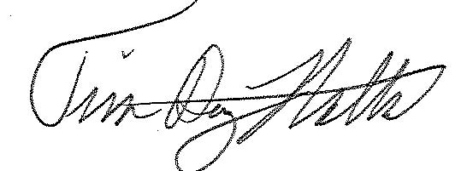

Tim Dewey-Mattia
Public Education Manager, NRWS/NCRWS
P.O Box 239
Napa, CA 94559
tim@naparecycling.com, (707) 256-3500 x1204

