Gary Liss & Associates
4395 Gold Trail Way, Loomis, CA 95650-8929
916-652-7850; Fax: 916-652-0485
gary@garyliss.com, www.garyliss.com

July 17, 2008

Mary Nichols, Chair
California Air Resources Board
1001 "I" Street
P.O. Box 2815
Sacramento, CA 95812

RE: DRAFT Scoping Plan and Zero Waste

Dear Chair Nichols:

I would like to commend the Air Resources Board on its leadership in the implementation of AB32 and specifically the development of the Draft Scoping Plan. I am a Zero Waste consultant primarily involved with developing Zero Waste Plans for communities throughout the country and documenting successes of Zero Waste Businesses (see attached biography).

First, I would like to urge you to include the recommendations of the CARB Economic and Technology Advancement Advisory Committee (ETAAC) regarding waste and recycling (pages 105-112), and the recommendations of Californians Against Waste and the California Resource Recovery Association (attached).

Second, I encourage you to include some additional specific recommendations on Zero Waste:
- Adopt Zero Waste as a goal of the Scoping Plan, as the CA Integrated Waste Management Board did in their 2001 Strategic Plan.
- When you encourage local and regional governments to develop Climate Action Plans, you should ask them to adopt Zero Waste as the goal for those Plans for their waste and recycling initiatives. The Institute for Local Self-Reliance have just highlighted that Zero Waste initiatives are the most cost effective and fastest way for local governments to impact climate change in their pioneering report Stop Trashing the Climate.
- As you look for tools for economic efficiency associated with climate change initiatives, all the Zero Waste Businesses that we have documented have saved money, reduced their liability from leaking landfills, and increased their efficiency. Over 2,800 businesses have adopted Zero Waste as a goal and 99% have already achieved zero waste to landfill. As a result, I suggest you challenge businesses to Adopt Zero Waste as a goal and that all major businesses develop Plans to achieve that goal, as part of the action items of the Scoping Plan.

Third, regarding fees for moving towards climate change, I have a specific proposal regarding landfill surcharges as a key tool for climate change. In many European nations, they have adopted significant fees on landfills of $20-40/ton to fund recycling programs and decrease greenhouse gases, largely in response to the European Union Landfill Directive that calls for the phase-out of organics from landfills. In San Jose, the combined fees and taxes on landfilling are over $19/ton, and they have one of the highest waste diversion rates in the state. Many communities have adopted different levels of landfill surcharges around the state to fund their programs to implement AB939.

I propose that the Scoping Plan call upon the State adopt a $20-40/ton Zero Waste Fee on landfills that would be structured as follows:
1. The Fee would be levied on all wastes disposed of in the state or transported for disposal out of the state, to ensure that wastes are not transferred out of state to avoid this fee.
2. The Fee would credit all local fees charged already. This would level the playing field, and not encourage wastes to be transferred from one county to another. For example, in San Jose if the state enacted a $30/ton fee, San Jose landfills would be levied at $30/ton (ZW Fee) - $19/ton (local fees), or $11/ton.
3. Half of the revenue from the Zero Waste landfill fee would be used to cover one-time costs of the General Fund, or as the local government match for state bond issues, structured as follows:
a. The amount of funds to be used would be proportional to the percentage of materials used in construction projects under the bond issue made of reused, recycled or composted materials.
b. These funds will decrease over time as the amount of wastes decreases to landfills. As a result, these funds should be viewed as only part of the repayment plan for the local match on bond issues. For example, it could provide the first five years of matches, while state or local governments adopt other funding sources to replace these funds. Then these funds would be phased out over the following five years, as wastes dramatically decrease.
4. Half of the revenues from the fee would go to adopt and implement local Zero Waste plans, policies, and programs, including:
a. Funding startup costs for Extended Producer Responsibility (EPR) programs for industries that agree as a condition of funding that they will adopt industry-wide fees for covering the costs of operations and maintenance of those programs.
b. Zero Waste plans for communities and businesses
c. Development, consideration and adoption of local Zero Waste policies, including policies to Reduce wastes, Redesign processes and programs to eliminate wastes, product and packaging takeback programs, and procurement of products that are environmentally preferable and sustainable.
d. Technical assistance and training programs, including:
i. Development of procurement documents to solicit Zero Waste services, including collection, processing and marketing services for discarded materials (only if incentives are included that make it more cost effective to eliminate and reduce waste than to continue wasting)
ii. Certification and training programs for skills and knowledge required to plan and implement Zero Waste programs
iii. Peer matching and consulting assistance, managed by a nonprofit recycling or Zero Waste organization (like CRRA)
iv. A Recycling Information Network using state colleges and universities to compile and analyze data locally while training students to enter this field and develop curricula and classes for training on Zero Waste.
d. Planning, engineering, permitting, siting, land acquisition, equipment and construction for the capitalization of Zero Waste programs (not operating costs, as these funds will be decreasing over time), including:
i. Reuse facilities
ii. Recycling facilities
iii. Composting facilities
iv. Resource Recovery Parks
v. Anaerobic digestion (but NOT landfills, “conversion technologies” or “transformation” facilities)
vi. Market development activities for reuse, recycling and composting

These funds should build on existing private, nonprofit and public programs first, and not duplicate existing investments. The state should work with the food industry, landscapers, and builders in planning programs and projects to absorb organics and materials from construction and demolition projects.

The above proposals are ones that I believe could gain broad support from local government and the recycling industry in the state. As the recycling industry has recently been documented to be as large as the automobile industry in the country, that type of support could be significant in advancing this proposal.

I encourage you to include these proposals as part of the Scoping Plan and implementation of your Global Warming initiatives.

I can be reached at 916-652-7850 if you would like to discuss these proposals further.

Sincerely yours,

Gary Liss

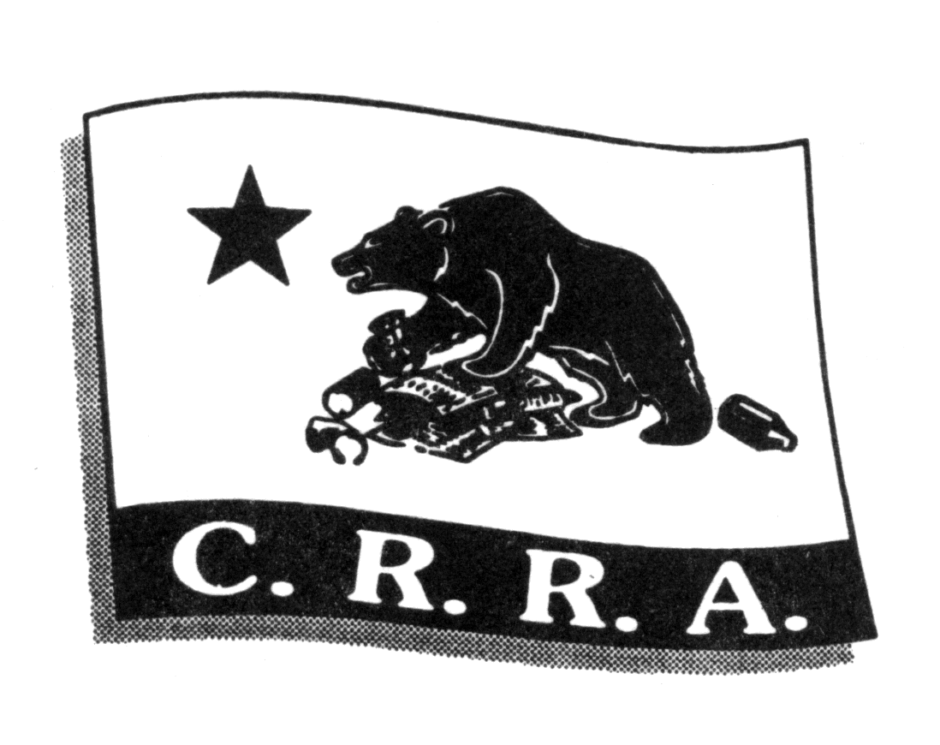

California

Resource

Recovery

Association

President’s Circle
Sponsors



City of San Jose
CA Integrated Waste Management Board
CA Department of Conservation
US EPA – Region 9
City of Los Angeles
StopWaste.Org
Green Waste & Zanker Road Landfill

The content of this letter has not been approved nor endorsed by the CRRA sponsors listed above.

P.O. Box 1228

San Luis Obispo, CA 93406

916.441.CRRA [2772]

Fax 916.676.4882

E-mail: crra@crra.com
www.crra.com

July 15, 2008

Mary Nichols, Chair
California Air Resources Board
1001 "I" Street
P.O. Box 2815
Sacramento, CA 95812

RE: California Air Resources Board's DRAFT Scoping Plan as it pertains to the recycling and waste management sector.

The California Resource Recovery Association (CRRA) is a statewide non-profit trade group. CRRA’s more than 550 members represent all aspects of California’s reduce-reuse-recycle-compost economy.
CRRA is disappointed that missing from CARB's draft Scoping Plan (http://www.arb.ca.gov/cc/scopingplan/document/draftscopingplan.pdf) are any of the following Zero Waste recommendations from Section 4. IV. (Waste Reduction, Recycling and Resource Management) of the CARB Economic and Technology Advancement Advisory Committee (ETAAC) report (http://www.arb.ca.gov/cc/etaac/ETAACFinalReport2-11-08.pdf):
J. Develop Suite of Emission Reduction Protocols for Recycling
K. Increase Commercial-Sector Recycling
L. Remove Barriers to Composting
M. Phase Out Diversion Credit for Greenwaste Alternative Daily Cover Credit
N. Reduce Agricultural Emissions through Composting

In fact, the only draft Scoping Plan preliminary recommendation related to Recycling and Waste is "RW-1 Landfill Methane Control" which is presented in Table 19 on pg. 35 of the draft Plan (http://www.arb.ca.gov/cc/scopingplan/document/draftscopingplan.pdf). This lone recommendation represents a narrow-minded strategy to mitigate the worst climate impacts of wasting AFTER failing to reduce, reuse, recycle, and compost.

IF California's commonly recyclable and compostable materials that are currently disposed as mixed waste were INSTEAD recycled and composted, THEN the GHG emission reduction would be over 25 million tons CO2 equivalence. This has been determined using US EPA's Waste Reduction Model (WARM) model and waste characterization data published by the California Integrated Waste Management Board (CIWMB), and has been verified by US EPA Region 9 staff.

The prioritized ordering of the waste reduction hierarchy to optimize resource conservation by reusing materials and repairing, refurbishing, and rehabilitating existing products and buildings to retain their form and function (and thus embodied energy) holds the potential for:
- substantially greater GHG reductions than recycling and composting alone; and
- creating ‘green collar’ jobs producing value-added contributions to the state’s economy.

This above bullet-points are explained and documented further in the recently-released report Stop Trashing the Climate: http://www.stoptrashingtheclimate.org

Zero Waste (i.e., reduce-reuse-recycle-compost) is a significant climate protection strategy which offers tens of millions of tons of CO2 equivalence GHG emissions reductions annually for California at low cost (compared to other options) using existing, proven, environmentally sound methods.
CIWMB’s Strategic Directives were adopted as “the most effective and efficient means to create a zero waste California.” The Directives (http://www.ciwmb.ca.gov/BoardInfo/StrategicPlan/) include specific steps to minimize waste (SD 3), move toward producer responsibility (SD 5) and support market development (SD 6). Inexplicably, none of CIWMB’s Strategic Directives are part of the draft Scoping Plan.

Thus, it is difficult to understand why CARB failed to include in the draft Scoping Plan any of the ETAAC report's Waste Reduction, Recycling and Resource Management recommendations. It is particularly difficult to understand this given that the governor’s Climate Action Team has already identified Zero Waste/High Recycling Programs as a "high-confidence" strategy with significant GHG reduction potential of 10 million tons CO2 equivalent by 2020 (see: http://climatechange.ca.gov/publications/factsheets/2005-06_GHG_STRATEGIES_FS.PDF). CRRA believes this 10 million tons CO2 equivalent by 2020 represents a conservative estimate of the emission reduction potential of Zero Waste in California.

California is off to a good start toward climate protection via Zero Waste, thanks to the California Integrated Waste Management Act of 1990 (AB 939) which mandated 50% waste diversion by 2000. It is critical that the Scoping Plan recognize and include Zero Waste California (i.e., reduce-reuse-recycle-compost) as the significant climate protection strategy that it is.

Finally, CRRA is holding its annual conference and tradeshow next month, August 3-6, 2008 in Burlingame, CA. The conference theme and focus is "Carbonopoly: Climate Change is Not a Game We Can Lose'’. We will be discussing the Scoping Plan, the ETAAC report, and more. This would be a great opportunity to educate and engage CARB Board members and staff on the significant GHG emissions potential of Zero Waste in California.

The conference program can been viewed at: http://www.crra.com/2008conf/sessions.html

Thank you for your consideration.

Sincerely,

Julie Muir, President
Gary Liss

Gary Liss has worked on more Zero Waste community plans than any other individual in the United States. He has over 35 years of experience in the solid waste and recycling field, was a founder and past President of the National Recycling Coalition and was Solid Waste Manager for the City of San Jose, CA. In San Jose, Mr. Liss developed their recycling programs into national models, which are currently diverting 62% of the overall waste stream. Mr. Liss has documented Zero Waste Businesses, developed Zero Waste Business Principles, helped the Salt Lake Olympics and the World Summit on Sustainable Development in Johannesburg achieve Zero Waste, and helped organize Zero In on Zero Waste business conferences. He helped write Zero Waste Plans for: Del Norte County, CA; Nelson, British Columbia; Palo Alto, CA; and Oakland, CA; and is now working on drafting Zero Waste Plans for the Cities of Los Angeles, Burbank and San Jose in CA, the Town of Telluride, CO, the City of Albuquerque, NM and the City of Austin, Texas. He is also working to help the Central Vermont Solid Waste Management District implement their Zero Waste Plan.

Mr. Liss is on the Planning Group for the Zero Waste International Alliance and is on the Sierra Club national Zero Waste Committee. He is also one of the founders of the Zero Waste for Global Cooling Coalition. In 2005, the Zero Emissions Research & Initiatives certified Mr. Liss as a ZERI Systems Designer. Also in 2005, Mr. Liss was recognized for his leadership by being selected as the CRRA Recycler of the Year. He has a Masters in Public Administration from Rutgers University and a Bachelor of Science in Civil Engineering (environmental major) from Tufts University.

www.nrc-recycle.org
http://www.grrn.org/zerowaste/business/profiles.php
http://www.grrn.org/zerowaste/business/index.php
see http://www.earthresource.org/zerowaste.html and an article in Fortune magazine: http://money.cnn.com/magazines/fortune/fortune_archive/2007/03/19/8402369/index.htm
http://www.cityofpaloalto.org/zerowaste/graphics/Strategic_Plan_FInal_100405.pdf
http://clerkwebsvr1.oaklandnet.com/attachments/14983.pdf
www.zwia.org
http://www.sierraclub.org/committees/zerowaste/
www.zeri.org
www.crra.com

