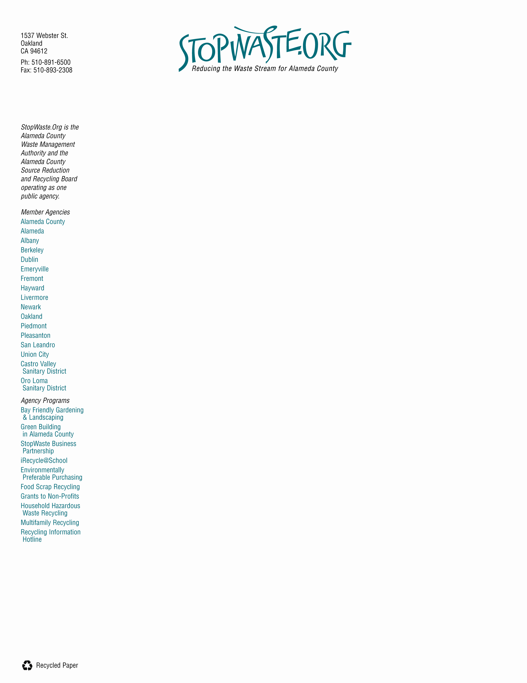
July 30, 2008

AB 32 Scoping Plan Comments

Recycling and Waste:

The current draft of the Scoping Plan should attribute greenhouse gas savings to waste reduction, recycling, and composting which are cost-effective and significantly reduce greenhouse gas emissions. Several of our cities get a significant portion of their projected greenhouse gas emission reductions from waste diversion.

On a statewide level, a 25% reduction in disposal would result in a reduction of at least 5 million tons of CO2 emissions. Waste reduction and recycling reduces emissions across sectors, including mining, forestry, agriculture, transportation, manufacturing, electricity, and disposal.

The appendices acknowledge the contribution from commercial recycling alone can be as high as 6.5 MMT, which is significantly higher than the potential reductions from landfill methane capture. The appendices also acknowledge a potential reduction of 3.1 MMT from increased composting. These items would be better placed in the main document and not in the appendix. While not quantified, extended producer responsibility and environmentally preferable purchasing are also valuable mechanisms for increased reductions. ARB should also encourage local and state government and business use of the EPA’s WARM tool for quantifying the emission reduction benefits of recycling and composting.

ARB should, at a minimum, adopt the recommendations of the ETAAC committee (Economic and Technology Advancement Advisory Committee). These recommendations include:

Develop emission reduction protocols for recycling to be used by local governments, businesses and the state
Increase commercial sector recycling via mandatory commercial recycling
Remove barriers to composting by addressing regulatory hurdles,
providing financial incentives for composting and use of compost, and
increase market demand through local and statewide procurement efforts.
Eliminate diversion credit for greenwaste used as alternative daily
cover.
Reduce agricultural emissions through composting.

Additionally, statewide landfill disposal limits for readily-recyclable materials like cardboard should be included in the plan as well as a recommendation for increased statewide diversion goals.

The ARB also needs to:

- Ensure the effective and comprehensive implementation of
already-adopted Early Action Measures on landfill gas collection.
- Improve GHG inventory and other landfill emissions models through
mandatory reporting and better quantification of fugitive emissions.

Green Building:

While it’s highly commendable that the Building Standards Commission recently approved the first set of statewide Green Building standards, contrary to the statement on page 23, the adopted standard will require 16 mandatory measures for the residential sector only by year 2011. The standards provide no more than voluntary measures for all other occupancies.

As stated in the intent section of the Green Building code, these standards are to be viewed as minimal Green Building Standards and that local government entities retain their discretion to exceed the standards established by this code. We recommend that the scoping plan include language to explicitly encourage local jurisdictions to implement green building standards, guidelines and rating systems that are more stringent than the state code and that the state address any obstacles for local jurisdictions to do so. We also recommend that the “green building standards, guidelines and rating systems” adopted by local jurisdictions be defined as a publicly available system, developed by a third-party, and includes a mechanism for evaluating and determining whether, and to what extent, a structure qualifies as a green building. This will assure a level of consistency and quality assurance throughout the state. This recommendation could be included in the Local Government Actions section of the report.

Thank you for the opportunity to comment.

Sincerely,

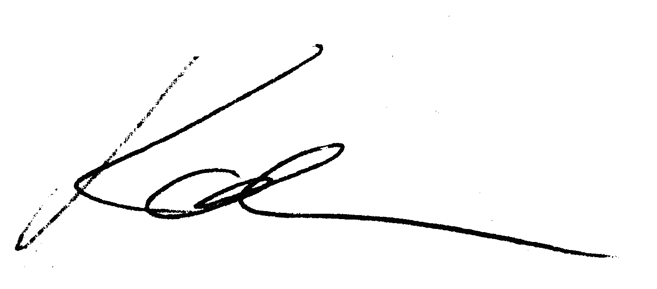

Karen Smith
Executive Director

