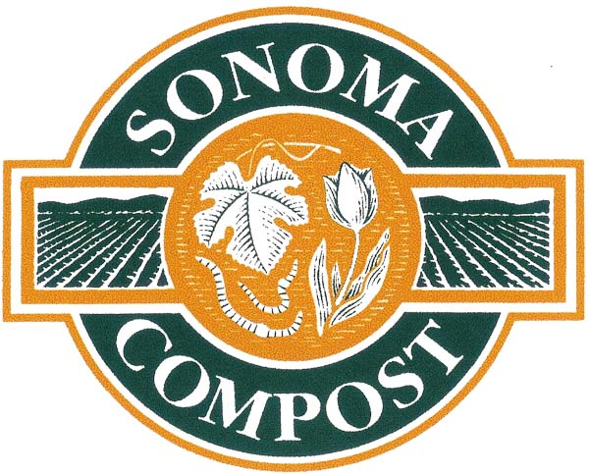

8-1-08

Mary Nichols, Chair
California Air Resources Board
1001 I Street
P.O. Box 2815
Sacramento, CA 95812

RE: Draft Scoping Plan and Organics

I would like to commend the Air Resources Board on its efforts in the development of the Draft Scoping Plan. I was pleased to see that comments to include recycling, zero waste and in particular composting have been incorporated into the latest draft. I am a composter in Sonoma County. Sonoma Compost diverts about 100,000 tons of organics from the landfill on an annually basis. All our composts and mulches are sold and most of the year demand exceeds supply. It is our believe that organics diversion and appropriate use in landscaping and agriculture will play a significant role in the goals set forth in AB 32. Our industry completes the carbon cycle on a local level.

I hope you will consider the following comments in the further development of the Scoping Plan:

- Ban organics (yard debris, food discards and wood products) from landfills, including the use of Alternative Daily Cover (ADC), which currently still gets diversion credits. Organics do slowly decompose in landfills producing methane. In reality, no more than 50 – 70% of the methane produced will be captured. The remainder will end up in the atmosphere where it is at least 23 times more potent as a greenhouse gas than carbon dioxide.
- Include in the evaluation of composting the benefits of reduced use of fertilizer and pesticides, water conservation, erosion control and carbon sequestration. Organic matter diverted from landfills and made into high quality compost and mulches can aid in the building of Soil Organic Matter (SOM). Increased SOM can significantly store carbon in the soil helping to reduce the amount of greenhouse gasses in the atmosphere.
- Include in the promotion of anaerobic digestion (AD) of manures the encouragement of AD for other organics such as food discards, which make up a significant portion of the waste stream produced in California.
- Explore the development of clean, efficient bio-fuel plants locally. Too much bio-fuel is hauled long-distance to bio-fuel plants. This energy can and should be produced and used locally.

I understand that the quantification of some these benefits are not easily obtained, but that should not be a discouragement to explore such great, easy to implement options. If you have any questions or like further information, please do not hesitate to contact me.

Sincerely,

Will Bakx
Sonoma Compost Co., LLC
550 Meacham Rd
Petaluma, CA 94952
Soil Scientist
707 479 8098
http://www.sonomacompost.com

