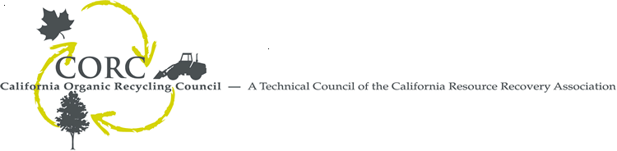

August 6, 2008

Mary Nichols, Chair
California Air Resources Board
1001 "I" Street
P.O. Box 2815
Sacramento, CA 95812

RE: California Air Resources Board's DRAFT Scoping Plan as it pertains to organics in the recycling and waste management sector.

The California Organics Recycling Council is a technical council representing the composting industry, including compost processors, mulch manufacturers, equipment vendors, biomass fuel makers, government officials, and non-profit organizations.
As our main focus is organics management, we feel that the CARB’s draft Scoping Plan did not adequately address the role that proper organic waste management must play in the reduction of green house gas (GHG) emissions. Specifically, the plan should have included measures to ensure that source separated green waste is kept out of landfills and is no longer disposed of or used for alternative daily cover (ADC) or any other “beneficial re-use” that would result in the green waste being buried in a landfill where it will produce methane. The plan should have also reflected the GHG reductions that can be achieved through the diversion of food wastes from landfills.
The Life Cycle Analysis currently underway in conjunction with the state Integrated Waste Management Board can provide more details about the benefits of composting organic waste as compared to landfilling them, as well as other key benefits such as carbon cycle improvements from applying compost to soils, and the GHG reduction potential of producing electricity and vehicle fuels from organic wastes rather than fossil fuels.
Overall, we feel that the draft Scoping Plan did not adequately address the green house gas reductions that would be possible through accepted best practices of waste prevention, recycling, and composting. We are surprised that none of the Zero Waste recommendations listed below, and outlined in the CARB Economic and Technology Advancement Advisory Committee (ETAAC) report (http://www.arb.ca.gov/cc/etaac/ETAACFinalReport2-11-08.pdf) were included in Section 4. IV. (Waste Reduction, Recycling and Resource Management) of CARB's draft Scoping Plan (http://www.arb.ca.gov/cc/scopingplan/document/draftscopingplan.pdf)
J. Develop Suite of Emission Reduction Protocols for Recycling
K. Increase Commercial-Sector Recycling
L. Remove Barriers to Composting
M. Phase Out Diversion Credit for Greenwaste Alternative Daily Cover Credit
N. Reduce Agricultural Emissions through Composting
While composting, anaerobic digestion, and waste to energy were listed in the document Appendix as “Other Measures Under Evaluation”, we feel that this reference lacks the timeline and importance of the original ETAAC recommendations. The one measure that was included in “RW-1 Landfill Methane Control” might help to mitigate the green house gas emissions caused by organics decomposing in landfills, but the most effective way to avoid such emissions is to stop landfilling organic materials in the first place.
CIWMB’s Strategic Directives were adopted as “the most effective and efficient means to create a zero waste California.” The Directives (http://www.ciwmb.ca.gov/BoardInfo/StrategicPlan/) include specific steps to minimize waste (SD 3), move toward producer responsibility (SD 5) and support market development (SD 6). Subdirective 6.1 addresses removal of 50% of organics in the waste stream by 2020, addressing the largest category of disposed materials. The compostable portion of organic materials constitutes approximately 30 percent, or about 15 million tons, of what is disposed. The paper and the woody portion of construction and demolition (C&D) debris constitutes another 15 or so million tons, all of which will add to methane gas production in landfill applications. Inexplicably, none of CIWMB’s Strategic Directives are part of the draft Scoping Plan.
The governor’s Climate Action Team has identified Zero Waste/High Recycling Programs as a "high-confidence" strategy with significant GHG reduction potential of 10 million tons CO2 equivalent by 2020 (see: http://climatechange.ca.gov/publications/factsheets/2005-06_GHG_STRATEGIES_FS.PDF). CORC believes this 10 million tons CO2 equivalent by 2020 represents a conservative estimate of the emission reduction potential of Zero Waste in California.

Zero Waste activities such as reducing, reusing, recycling and composting have been identified as valuable climate protection factors by the Governor, as well as ETAAC. CORC is requesting that the ETAAC recommendations be included as critical strategies in the final scoping plan.

Thank you for your consideration.

Sincerely,

Michele Young
CORC Board Chair

