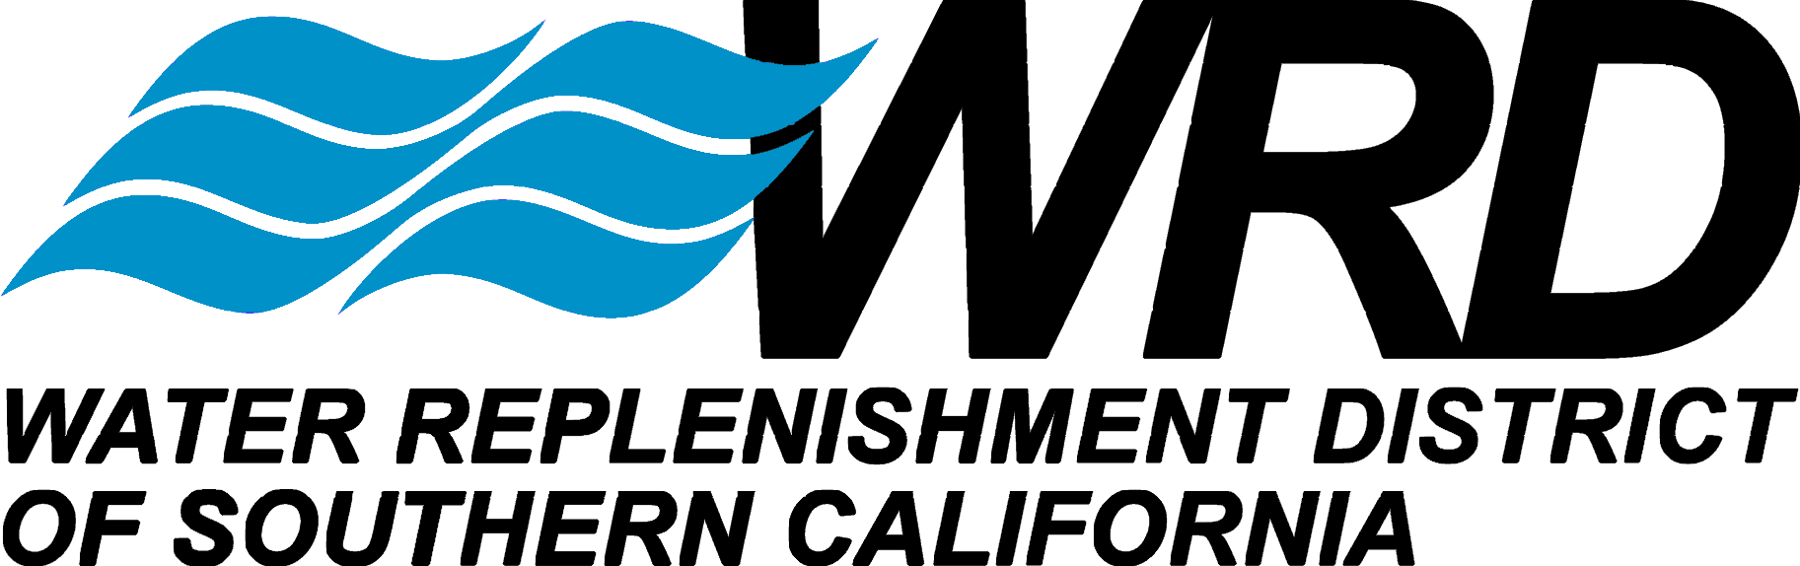
DIRECTORS
ROB KATHERMAN, PRESIDENT
LILLIAN KAWASAKI, VICE PRESIDENT
SERGIO CALDERON, TREASURER
WILLARD H. MURRAY, JR., SECRETARY
ALBERT ROBLES, DIRECTOR

ROBB WHITAKER, P.E. GENERAL MANAGER
4040 Paramount Boulevard, Lakewood, California 90712, Phone (562) 921-5521, Fax (562) 921-6101, www.wrd.org

August 11, 2008

To whom it may concern,

WRD met with the Natural Resources Defense Council and received a presentation of their Low-Impact Development (LID) program. The LID program can provide increase capture and infiltration of stormwater. In the WRD service area in the Los Angeles Coastal groundwater basin, this can reduce the need to import water through the California State Water Project Aqueduct and the Colorado River Aqueduct watershed to replenish groundwater supplies. This increases local reliability of groundwater supplies. Reducing demand for water pumped through these aqueducts can also reduce greenhouse gas (GHG) emissions associated with the use of those facilities. WRD believes that there is a significant potential benefit through the LID program that warrants further analysis by CARB.

Sincerely,
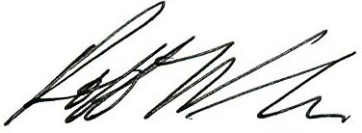
Robb Whitaker
General Manager
12621 E. 166th Street, Cerritos, Californa 90703 Phone (562) 921-5521 Fax (562) 921-6101
12621 E. 166th Street, Cerritos, California 90703, Phone (562) 921-5521, Fax (562) 921-6101, www.wrd.org

Sincerely,

[Your Name]

cc. [cc 1]
[cc 2]

