January 26, 2010

Mr. James Goldstene
Executive Director
c/o Clerk of the Board
Air Resources Board
1001 I Street
Sacramento, CA 95814

RE: Proposed Modified Regulatory Language for 15-Day Comment Period: REGULATION TO REDUCE GREENHOUSE GAS EMISSIONS FROM VEHICLES OPERATING WITH UNDER INFLATED TIRES

Dear Mr. Goldstene:

I am writing on behalf of the Tire Industry Association (TIA), which is a national organization representing over six-thousand tire retailer, wholesaler, retreader and recycler members with over fifteen-thousand locations. We currently have over five-hundred members in California. TIA is very troubled by certain language in Section 95550 (c) Definitions, (14) “Unsafe Tires”:

We are in complete agreement with the proposal that prohibits Auto Service Providers from inflating unsafe tires. However, TIA strongly believes that the inclusion of tire “age” alone as a criterion for declaring a tire unsafe is an assumption that is not supported by any scientific consensus. As I’m sure you are aware, this concept of tire age alone as a safety factor is still part of a legitimate industry debate and its deliberate misuse has contributed to the ever-growing instances of litigation. TIA has long-supported the notion that the determination of the significance of tire age as a safety factor should fall under the purview of the National Highway Traffic Safety Administration and/or the National Academy of Sciences (NAS).

Until such determination is made TIA respectfully suggests changing the wording in Section 95550 (c) Definitions, (14) “Unsafe Tires” - as follows:

"Unsafe Tires" means any tire considered unsafe in accordance with standard industry practices, due to tire tread wear, age, tread irregularity, or damage. Examples include any tire with exposed ply or cord, sidewall crack, bulge, knot, or ply separation.

Thank you for the opportunity to comment on this proposed regulation that has far-reaching implications for our members.

Sincerely,

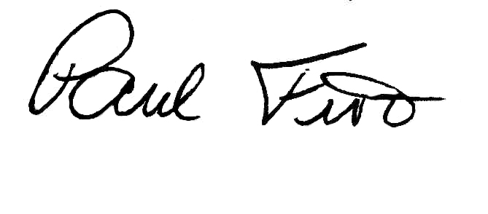
Paul Fiore
Director of Government and Business Relations

