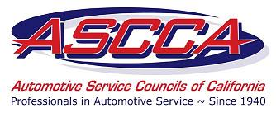

Automotive Service Councils
Of California

One Capitol Mall, Suite 320
Sacramento, California 95814
(916) 924-9054
(800) 810 4272
FAX (916) 444-7462
E-mail: Info@ASCCA.com

VIA FAX 916.322.3928 & MAIL

January 28, 2010

Clerk of the Board
Air Resources Board
1001 I Street
Sacramento, California 95814

RE: Proposed Amendments to Regulation to Reduce Greenhouse Gas Emissions from vehicles Operating with for Under Inflated Tires-Deadline for Public Comment: January 29, 2010

Dear Clerk:

The Automotive Service Councils of California (ASCCA) is a statewide organization that represents 1,000 automotive repair facilities in the State, including smog shops.

ASCCA has participated and been actively involved in the under inflated tire regulation process from its inception. ASCCA representatives and members have attended workshops and provided comments and suggestions to improve the regulation for both repair shops and consumers. The ASSCA has also provided written comments to the previous versions of the regulation.

The original intent was to simply codify, into regulation, the exiting voluntary practice of checking and inflating tires. The current practice is very simple and straightforward.

Unfortunately, the latest version of the regulation creates unnecessary costs and administrative burdens for both repairs shops and consumers by requiring an unreasonable amount of documentation. Furthermore, it subjects both repair shops and consumers to severe penalties even for simple oversights or mistakes. This process started out as a good idea but now has become so convoluted and complicated that it will create many unintended consequences:

ASCCA has the following specific comments and suggestions:

- Section 95550 (d) (5), which requires consumers to prove that they performed a tire check and inflate service within the last 30 days and provide supporting documentation or agree to perform a tire pressure check and inflate service within the next 7 days, which must be documented on the repair shop invoice, is unnecessary and frankly over the top.

The customer should have the right to decline the check and inflate service. Period. Requiring evidence and documentation that they performed or will perform is unnecessary. The entire section should be deleted.

- The proposed regulations should apply to all automotive service providers registered with the Bureau of Automotive Repair (BAR) that perform automotive repair services.

- It is unclear as to whether the service provider must check inflation of vehicle tires while the tire is “hot” or wait for a period of time and check when the tire is “cold”. This concern has been raised in prior correspondence and at the Air Resources Board workshops. It still has not been adequately addressed in the latest version of the regulations.

- As you are well aware, the BAR has regulatory oversight of the automotive repair dealers in the state. BAR has the expertise and personnel to properly oversee the enforcement of this proposed regulation rather than the Air Resources Board. We hereby request that the BAR act as the authorized representative to enforce this regulation under existing law and that the proposed amended regulations reflect such enforcement. Furthermore, we request that section 95550 (e) Penalties and Injunctions be deleted.

The regulation, as drafted, will create another layer of unnecessary administrative paper work, increase in costs, frustration and confusion for both the repair shop and the customer. We respectfully request that revisions be made to address the above concerns, or in the alternative drop the regulation and allow the automotive industry to continue to provide check and inflate service on a voluntary basis.

Sincerely,

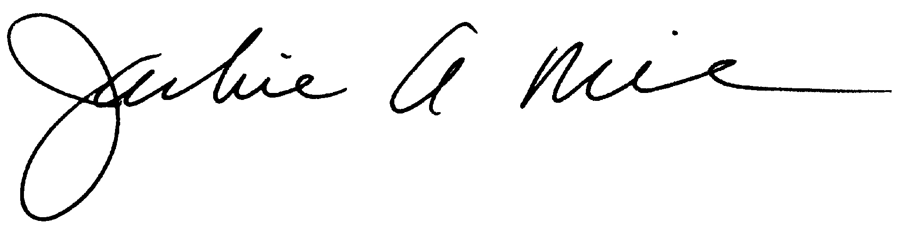
Jackie A. Miller for
Craig Johnson, Chair, Government Affairs Committee

CC: ASSCA Board of Directors
ASSCA Government Affairs Committee
Jack Molodanof, ASCCA Legislative Advocate

