CENTRAL CAL TRANSPORTATION
P.O. Box 12084
Fresno, CA 93776
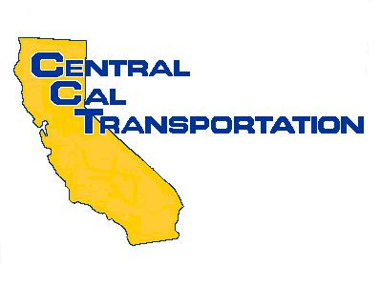

CENTRAL CAL TRANSPORTATION
Post Office Box 12084
Fresno, CA 93776
Telephone (559) 237-8700
Fax (559) 237-8744

October 7, 2009

California Air Resources Board
Post Office Box 2815
Sacramento, CA 95812-2815

Attn: Mike Sutherland

Re: Drayage Truck Pushback

I am writing this to you in response to some increasing chatter in the Drayage Industry about a possible pushback in the January 1, 2010 date for compliance with the regulations concerning our segment of the trucking industry. I would like to be on record that I strongly oppose such a pushback on this date.

Central Cal Transportation is a drayage company operating primarily out of Oakland but I also run trucks out of the ports in Southern California. Over the past two years, we have invested heavily by purchasing 28 new trucks in anticipation of the implementation of these regulations at a cost of over $3,500,000.00 in private funding. I have also attended many district meetings and have tried to stay current on all the changes that have happened over the past year or so, with the only constant being the January 1, 2010 implementation date.

In the past week, I have ordered another 40 brand new trucks at a cost of over $4,800,000.00 using private funds for delivery in December to supplement our fleet. I also planned on ordering an additional 40 brand new trucks by the end of October to bring our fleet of trucks up to 119 plus an additional 100 or more existing Sub Haulers leased on with our company that have also upgraded, or are in the process of upgrading their equipment. What can I tell these small businessmen who have put up everything that they have on my word that they must upgrade or leave the industry.

If this deadline is pushed back, I will be at a disadvantage in the industry as I will be competing for freight with competitors who have not stepped up to the plate and can skate by with their old equipment. The extra cost on running this new equipment is $150.00 per day. There is not $150.00 profit per day to be made on any of the freight that I haul and this could have the effect of putting us out of business and rewards those who have sat on the sidelines.

I urge you to proceed with the implementation of the January 1, 2010 implementation date so that there may be a level playing field for all of the drayage trucks to play on. I have done my part and have acted in good faith by purchasing trucks way in advance of the date and have been eating this additional cost for the past year or more. I take my responsibility to help clean the air very seriously and do not want to jeopardize my company’s future due to doing the right thing by meeting your requirements for emission reduction.

Everyone involved in this industry has had the opportunity to upgrade or replace their equipment and this is nothing like the Refrigerated Trailer pushback that was granted due to a lack of available upgrade technology. This is purely and simply, a level and equal playing field that the entire industry can make decisions on and will ensure the sustainability of this industry.

I hate to even bring up the point of the litigation that will surely ensue, if the date gets pushed back, as CARB has given its word that the date is set, as well as my word given to my Sub Haulers, and there is quite a bit riding on this date. I thank you for your consideration in this very troubling matter and I realize that there is no easy decision to be made. The only fair outcome, from my perspective, would be a level playing field where I am not at a disadvantage when I have done everything in my power to meet your requirements for compliance. Do not reward the people who have sat on the sidelines and done nothing to comply.

Sincerely,

David B. Chidester
President
Central Cal Transportation

