Tom Frantz
30100 Orange St
Shafter, CA 93263

November 6, 2008

California Air Resources Board

Re: new proposals for diesel trucks in the San Joaquin Valley

In reference to the staff report titled Initial Statement of Reasons for Proposed Rulemaking found at this link, http://www.arb.ca.gov/regact/2008/truckbus08/tbisor.pdf
and copied, in part, just below this paragraph, I wish to make a few comments.

The above exceptions and delays for compliance of agricultural vehicles contain at least one serious loophole and other possible problems.

First, the pictures below, taken in October of 2008 in Kern County, show corn silage harvest trucks that spend many hours per day idling under load through fields while being loaded by a harvester such as a combine. These trucks then quickly deliver the harvested crop to a nearby dairy or feedlot and return to the field again to slowly pick up another load. The hours spent in the field represent many more miles than what the vehicle’s odometer will show and gives the truck the equivalent of thousands of extra miles. These extra hours could effectively put the vehicle over the limits shown above but without hour meters on the engines no one would know.

Another problem is these kinds of harvest trucks do not seem to fall under the specialty truck category mentioned above. The owners of these trucks used almost exclusively in harvesting may find it cheaper to buy several old trucks and keep their individual mileage under the 10,000 miles, or other mileage exemptions, instead of purchasing a newer truck that meets the new guidelines for emissions.

I hope these issues will be looked at seriously and remedied as possible.

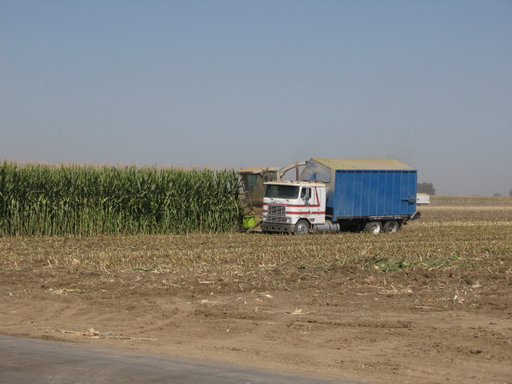

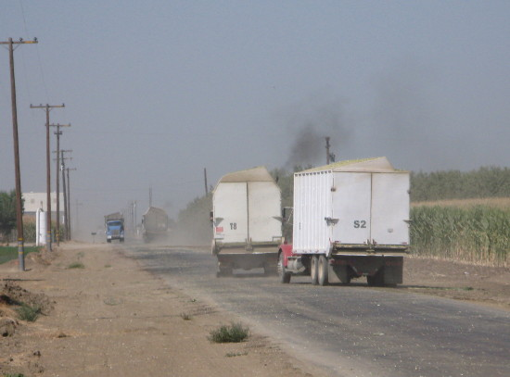

Sincerely,

Tom Frantz
President, Association of Irritated Residents

