November 20, 2008

Comments of the National Armored Car Association Regarding Proposed Idling Regulations under Title 13 CCR Sections 2485(d)(2)(M) and 1956.8(a)(6)(B)

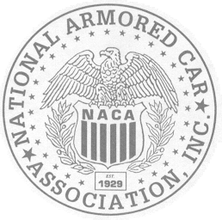The National Armored Car Association strongly supports the proposed exemptions from limits on engine idling.

In issuing Advisory 349 on March 18, 2008, the Enforcement Division recognized the need for armored car crews to idle on occasion for more than five minutes. The exemption is consistent with the recommendations of US EPA as outlined in its model rule on diesel idling. The proposal would codify the advisory.

For the same health and safety reasons, the exemption from the requirement for an engine shutdown after five minutes is critical as well. Armored vehicles and their crew members are the targets of violent criminal attacks because of the millions of dollars of currency and other valuables they carry. When these attacks occur, the driver must be able to move the vehicle away from the location at a moment’s notice. Quick action is necessary to protect our crews from the risk of serious injury or death. Requiring the driver to add an additional step to start the vehicle could mean the difference between life and death.

We are pleased that staff recognized that drivers of armored cars would not be able to “tap the accelerator” every five minutes to avoid engine shutdown. That requirement would significantly hamper the driver’s ability to effectively operate from his command post in the vehicle. These crew members are not merely drivers who sit and wait while their partners make deliveries. They are highly trained security personnel who must remain alert, keeping an eye on their fellow crew members and continually scan the surrounding area for potential attackers.

Our drivers are not always able to remain in their seats. To get a view of the delivery, they often will move to the messenger (passenger) seat or to the storage area of the vehicle. At the same time, they may be calling their partner, the police or home office to report suspicious behavior. The driver is also responsible for operating emergency lights, cameras, sirens and other security devices used for the protection of the truck and its crew.

As the Board considers these proposals, we stand ready to respond to any questions you may have.

Submitted by Lawrence Sabbath, Executive Director

9532 Stevebrook Road Fairfax, VA 22032-2032
Phone: (703) 426-1976 Fax (703) 666-9085
www.nationalarmoredcar.com

