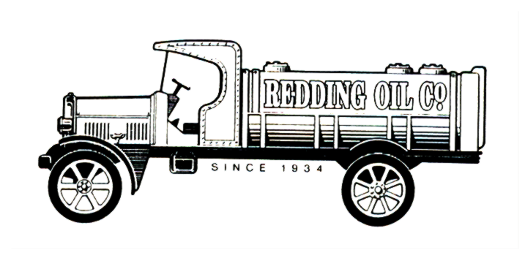
December 5, 2008

California Air Resources Board

Dear Members of CARB:

Although the goal of the regulation is very much worthwhile, we believe the on-road truck and bus rule could not come at a worse time for the trucking industry. For those that were able to scrape by after record-high fuel prices earlier this year, they now have a very tough road ahead trying to gain back ground in a severely slumping economy. And for those of us also in the petroleum distribution sector, trying to fund truck upgrades shortly after EVR and ISD is not going to be easy.

With the problems many fuel retailers are experiencing with ISD as an example, we think this diesel emission legislation is also coming before the technology has a chance to prove itself as a worthy investment. Over half of our fleet of 8 trucks is pre-1994 and not worth spending money on PM BACT. They will have to be retired or replaced with 2010 engines very soon after the engines first become available.

Purchasing four new trucks would cost nearly ½ million dollars and would generate zero additional revenue, just like the case with EVR & ISD for our 8 locations. These expenditures come too soon together for them to be funded by operating income and I do not think there are very many banks who will loan a $1,000,000 in today’s economy to a company that cannot demonstrate how it will be paid back.

If the implementation period for this legislation were to be lengthened, most of the above problems would be solved. We feel our facility upgrades justify an extended timeline and support DTCC on behalf of our numerous independent trucker customers who would benefit from the flexibility of their proposal.

Sincerely,

Vince Reiser
Redding Oil Company

