B J SERVICES

Date: 12/8/08

To: Clerk of the Board
Air Resources Board
1001 I street
Sacramento, CA 95817

Subject: Cost of Engine Replacement for ATCM & PERP

Honorable Board Members,

BJ Services (BJS) appreciates the opportunity to participate in the development of the On- Road truck regulation, as we have in the PERP & Off Highway Regulations.

BJS is a High Pressure pumping service for the oil industry. We provide cementing and well stimulation services to increase production of oil & gas wells.

BJS was founded 136 years ago in Woodland California. BJ is now a world wide publicly owned company. BJ currently employs 171 people in our California operations.

As with all publicly owned companies, BJS is required to generate a return on investments. California districts have to compete with BJS districts world wide for capital funding to purchase new equipment or engines. If a district can not generate the required return on investment, BJS will not allocate the funds.

Due to the current economic turmoil BJ services California division is expecting a decline in revenues below our 2008 sales.

Consequently our capital budget for 2009 has been drastically reduced. It would have been reduced more, however we have 6.5 million dollars of PERP equipment being constructed that was ordered in 2007-08 for 2009 delivery that we can not cancel.

Currently 70% of the oil & gas produced in California comes from three major oil companies. That means instead of having a customer base of thousands to help recover any cost increase to BJS operations in California, our costs are spread over less than a dozen customers.

Please keep this in mind as you review the costs for engine & equipment replacement on the following pages.

BJS PERP Engines already Replaced & Related Cost

1 each 1998 @ 420 Hp------------------ Re-power cost-------------------------$25,000.00
1 each 2001 @ 152 Hp------------------Re-power cost--------------------------$15,000.00
2 each 2001 @ 315 Hp------------------Complete new pump truck------ $1,000,000.00
1 each 2001 @ 630 Hp------------------Re-power Cost ------------------------ $28,000.00
1 each 2002 @ 600 Hp------------------Re-power Cost -------------------------$28,000.00
1 each 2002 @ 630 Hp------------------Re-power Cost------------------------- $28,000.00
9 each 2004 @ 110 Hp------------Re-power cost @ $10,000 ea.---------- $90,000.00
2 each 2004 @ 2250 Hp2 complete new Frac pumps @ 1 mil. Ea.--- $2,000,000.00
1 each 2005 @ 85 Hp-------------------Re-power Cost --------------------------- $9,000.00
4 each 2005 @ 110 Hp-----------------Re-power Cost @ $10,000 ea. ------$40,000.00
4 each 2005 @ 665 Hp-2 complete new Cement pumps @ 1 mil ea.-$2,000,000.00
3 each 2005 @ 2250 Hp—3 complete new Frac pumps @ 1 mil ea---$3,000,000.00
1 each 2006 @ 240 Hp------------------Re-power Cost --------------------------$15,000.00
3 each 2006 @ 2250 Hp---3 complete new Frac pumps @ 1 mil ea---$3,000,000.00
10 each 2007 @ 665 Hp-5 complete new Cement pumps @ 1 mil ea.$5,000,000.00
2 each 2008 @ 110 HP------------------Re-power Cost --------------------------$10,000.00
2 each 2008 @ 130 Hp------------------Re-power Cost---------------------------$30,000.00
Total Cost since 1998 --------$16,318,000.00

BJS PERP engines to be replaced by 12/31/09

1 each 1974 @ 127 Hp------------------Re-power Cost ------------------------- $10,000.00
1 each 1975 @ 120 Hp------------------Re-power Cost ------------------------- $10,000.00
1 each 1978 @ 120 Hp------------------Re-power Cost ------------------------- $10,000.00
1 each 1980 @ 99 Hp--------------------Re-power Cost ----------------------- --$10,000.00
1 each 1978 @ 318 Hp------------------Re-power cost--------------------------- $15,000.00
2 each 1980 @ 335 Hp------------------Complete new pump truck------ - $1,000,000.00
1 each 1980 @ 400 Hp------------------ Re-power cost-----------------------$25,000.00
2 each 1980 @ 478 Hp------------------Complete new pump truck------ - $1,000,000.00
1 each 1980 @ 1800 Hp------------------Complete new pump truck------ $1,000,000.00
1 each 1980 @ 2000 Hp------------------Complete new pump truck------ $1,000,000.00
1 each 1981 @ 127 Hp------------------Re-power Cost -------------------------- $10,000.00
4 each 1981 @ 478 Hp-2 complete new Cement pumps @ 1 mil ea.--$2,000,000.00
4 each 1981 @ 1600 Hp—4 complete new Frac pumps @ 1 mil ea----$4,000,000.00
1 each 1983 @ 440 Hp------------------ Re-power cost-----------------------$25,000.00
1 each 1990 @ 181 Hp------------------Re-power cost---------------------------- $15,000.00
1 each 1993 @ 110 Hp------------------Re-power Cost----------------------------$10,000.00
1 each 1995 @ 160 Hp------------------Re-power Cost--------------------------- $15,000.00
1 each 1995 @ 335 Hp ------------------Re-power cost----------------------------$25,000.00
2 each 1995 @ 300 Hp------------------Complete new pump truck---------$1,000,000.00
Total Cost for 2009 ------------$11,180,000.00

BJS Off Highway & Fork Lift replacements for 2009

5 each 6000 Lb fork lifts @ $24,000.00 each ----------------------------------$120,000.00
3 each 10,000 Lb fork lifts @ $40,000.00 each --------------------------------$120,000.00

Total replacement cost for 2009 ---------$240,000.00

BJS On Highway vehicle replacement

49 each Pre 1998 trucks replacement cost of $150,000.00 each----------$7,350,000.00
48 each 2000 to 2006 trucks for VDECS @ estimated $7,000.00 ea-------$336,000.00
48 each 2000 to 2006 trucks needing 85%Nox reductions @ $7000.00---$336,000.00 Estimate
Estimated total expense before 2013--------$8,022,000.00

48 each 2000 to 2006 trucks to be phased out by 2020 after spending $336000.00 on them for retrofits, replacement cost @ $150,000.00 ea. = $7,200,000.00

- VDECS & NOx requirements
Staff has recommended that we need particulate traps and a NOx device that will reduce NOx by 85%.

BJS major concern is that only one current device reduces NOx by 40% which falls short of the required reduction of 85%. The staff report states that despite the potentially substantial NOx reductions SCR can provide, exhaust temperatures (or duty cycle limitations) will likely dictate the actual suitability of certain vehicles to use SCR or other NOx-control technologies in exhaust retrofit applications.

- Suggested modification to Proposed Regulation
BJS suggests that we adopt a regulation that allows industry to purchase currently available PM traps with lower NOx levels, and allow them to be operated until 2017 without any other modifications.

This would allow industry to purchase currently available technology and operate the vehicles for 8 years, without any other major expense for add on’s, until we could replace them with newer vehicles.

Staff will argue that they need 85% NOx reductions to meet their SIP.
This may be true, however they have exempted school buses from needing any
NOx reductions at all!

The staff report states, “School age children are an especially vulnerable segment of our population to the affects of air pollution.” However, school districts are allowed to use 1977 model Tier “0” school buses forever if retrofitted with a VDECS by 2014, with zero NOx reductions.

- Body Load Trucks

Body load trucks are vehicles that have permanently mounted machinery on the back frame of the truck in order to perform a specific job function. They may have an auxiliary engine mounted on the rear of the unit or they may be operated in PTO mode by the highway engine.
These vehicles have a fixed load that normally can not be removed in one large piece because it is constructed onto the truck frame, using the frame as a backbone of the unit.
This is done to conserve weight by not having a separate frame, to keep the truck DOT weight legal for the highway.

These are three examples of Body Load trucks.

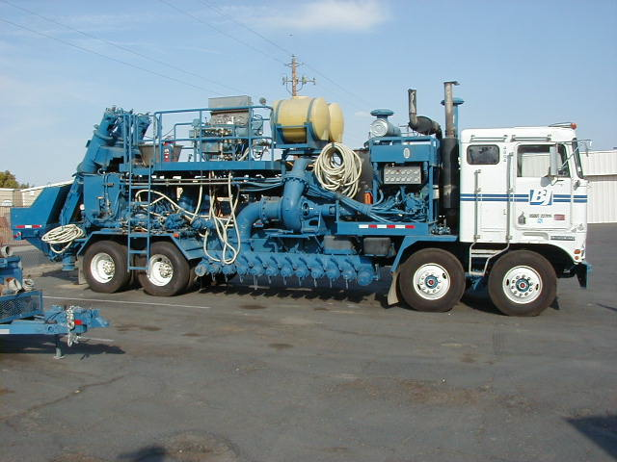

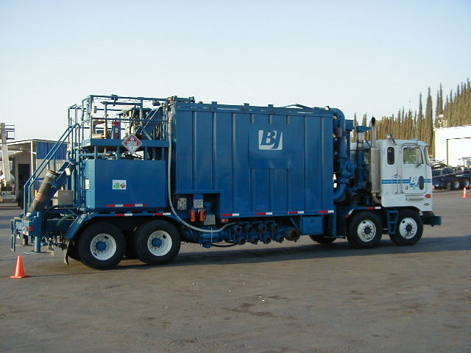
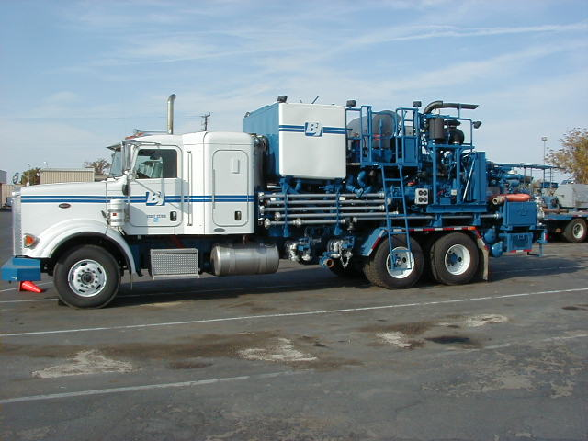
Note that because the machinery is built onto the frame of a body load truck, it is often more expensive to remove it and replace it on a new truck than the cost of the new vehicle.
- Body Load suggested change to Proposed Regulation

Due to the high cost of transferring body load equipment from one truck to another. BJS suggests that we allow body load trucks to be included in the special mileage limitations provided for agricultural vehicles. If body load trucks operate below specified annual mileage limits (25,000 mi.) they would be exempt from PM & NOx requirements until 2017.

BJS requests that Body Load trucks are given the same consideration due to large capital expense as CARB has allowed to dual engine cranes & sweepers, cab over trucks pulling 57-foot trailers.

- Adding Vehicles to a Fleet

“If a fleet does not meet the BACT requirements of the section 2025(f), before the fleet may operate a newly added vehicle in California, it must within 30 days of adding the vehicle file a report with the Executive Officer that it has added a new vehicle, and demonstrate that the fleet, as newly constituted with the requirement of section 2025 (n) (2) (A) and (B).” Fleet owners will purchase several new vehicles at the beginning of the year, but will receive the new vehicles throughout the year. The proposed regulation would require fleet owners to file several reports each month to the Executive Officer to remain in compliance with the regulations, this is very labor intensive.

- BJS Suggested change to the Proposed Regulation

BJS suggests to modify the proposed regulation stating that the addition of new 2010 model trucks, which do meet the final requirement, will not be required to file a report with the Executive Officer. The addition of new 2010 model trucks to a fleet will help the fleet move closer to compliance. This modification will reduce costly red tape built in to the proposed regulation.

- Staff recommended Modifications to the PERP Regulations

Staff is proposing to make modifications to the PERP to allow unregulated Tier 0 secondary off-road engines on cranes and sweepers to be newly registered under PERP. These engines would then only be subject to the inspection requirements and fees listed in the PERP regulation. Does this mean that these Tier 0 engines will be allowed to operate passed January 1, 2010? The CARB Board adopted the PERP regulation in September 1997. As part of the regulations, all fleet owners were required to replace all Tier 0 engines by January 1, 2010. In addition, fleet owners were required to repower engines with certified engines starting in July 2001, which did not allow replacement of Tier 0 engines with another Tier 0 engine.

By CARB allowing the PERP to be modified once again is another slap in the face for industries that have been working hand in hand with CARB through the PERP process.

As you have seen in this report BJS has spent multi-millions of dollars to make our fleets comply with CARB regulations since 1998.
Allowing industries to come into the PERP and exempting them from the rules that we all had to follow means that CARB is providing a competitive edge to those companies!

The staff report states, “Currently, non-registered Tier 0 secondary engines on cranes and sweepers are not allowed to be registered through PERP.” Tier 0 engines were allowed in the PERP in 1997, 1998, 2002 and 2005 through multiple amnesty periods. If a fleet owner did not register during the amnesty periods, they were not allowed in the PERP and could be permitted under the local air districts.

The staff report states, “For the regulation to be fair to fleets that would spend considerable funds and efforts to comply, fleets must be assured that their competitors would also be complying.” Another statement, “Staff recognizes that creating a level playing field for all affected fleets is important.” How does staff develop a level playing field with companies that have spent considerable funds complying with PERP over the past twelve years?

BJS would like to comment on the following statements found in the staff report:

- “Staff expects many, if not most, affected businesses to pass through the proposed regulation’s costs to their customers.” Staff does not understand that several affected businesses operate under contracts for years and are not allowed to change prices until the end of the contractor the complete contract can be sent out for re-bid.

- “Staff believes many fleets would be able to absorb the costs of the proposed regulation if they were unable to pass through the costs.” As stated earlier, BJS sales forecast for 2009 predicts a sharp decline in revenue compared to 2008.

- “Also, while many fleets subject to the proposed regulation are also subject to other ARB regulations, staff does not believe the cumulative cost impacts of these various regulations will impact affected fleets’ ability to comply overall.” Several industries like the petroleum services, construction, and rental are regulated by the Portable ATCM, the Off-Road ATCM and the On-Road ATCM and the ForkLift ATCM. All of these regulations required repowering equipment, replacement and installation of VDECS.

- “The proposed regulation would impose a cost on the overall economy; staff expects it could reduce overall employment in California by a small amount. In 2013, the highest cost year, employment would be expected to decrease by about 4,600 to 13.600 jobs.” In the Health Impact Methodology, staff reported the cost over a period from 2010 to 2025. Using the same methodology, the proposed regulation could reduce employment in a range of 89,000 to 244,000 jobs.

- “Fleets naturally replace their vehicles on a regular basis that is faster than what the regulation would require.” Many fleet owners like BJS will utilize the vehicles in their inventory from 10 to 25 years.

If you have any questions about my suggestions in this letter, please contact me at 661-342-9707.

Thank you for your time, Doug Van Allen

Doug Van Allen
Sr. District Safety & Training Supervisor
BJ Services Company USA
1431 S. Union Ave.
Bakersfield, CA 93307
Cell 661-342-9707
Fax 661-831-2685

