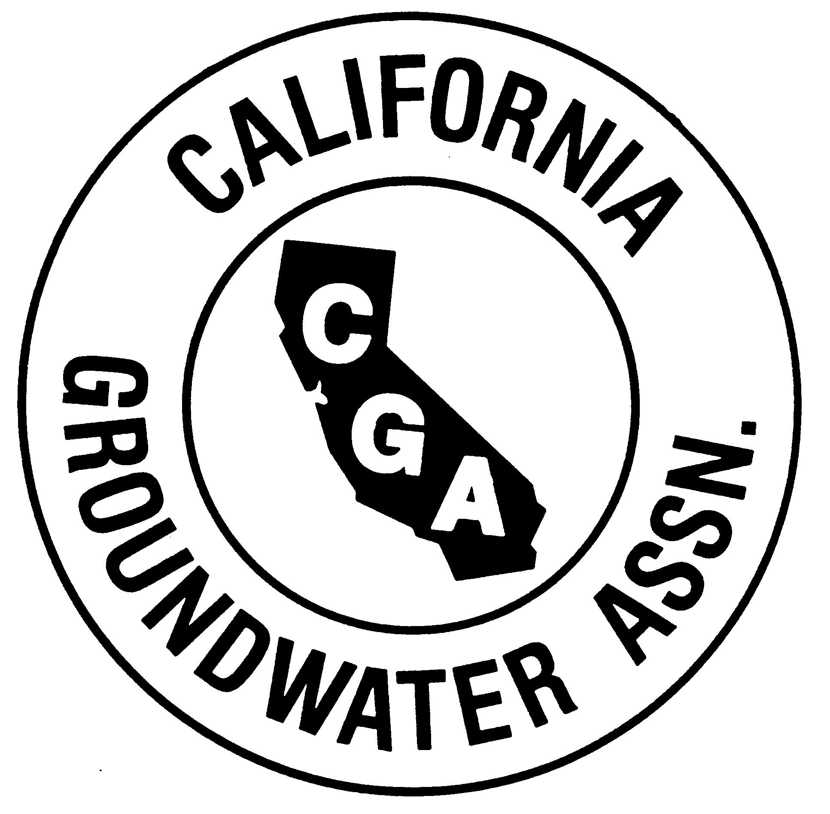

California Groundwater Association
An NGWA Affiliate State
P.O. Box 14369  Santa Rosa, CA 95402  (707) 578-4408
Fax: (707) 546-4906  email: wellguy@groundh2o.org

Established 1948

December 9, 2008

Mary Nichols, Chairman
California Air Resources Board
1001 I Street
Sacramento, CA 95814

Dear Chairman Nichols:

Re: Request for Modification of On-Road Diesel Truck and Bus Regulation

On behalf of the members of the California Groundwater Association, we are requesting that the California Air Resources Board make modifications, as noted below, to the proposed On-Road Diesel Truck and Bus Regulation. For the last 60 years, the California Groundwater Association (CGA) has represented the groundwater industry in the state. Our members include water well drilling and pump installing contractors, industry manufacturers and suppliers and technical experts such as geologists, hydrologists, engineers and others in the private sector and government.

CGA represents about 430 groundwater contracting firms employing about 2,440 persons. Non-contractor firms (1200) employ about 37,500 persons in the industry. The groundwater industry is not large in numbers but its functions are critical to the state’s wellbeing. In times of drought, groundwater supplies up to 50% of the state’s water needs. As you are well aware, California is experiencing insufficient water supplies, as it has in the past. The groundwater industry has been able to help meet past challenges of droughts but reduction of the industry’s capability to provide groundwater will have adverse affects to all citizens of the state.

Current and proposed CARB regulations will lead to reduced capability to provide groundwater supplies unless modifications are made. The groundwater industry deals with complex geology and hydrologic conditions throughout the state and must utilize a wide variety of equipment in order to develop groundwater supplies for the state’s needs. Much of that equipment is quite specialized and has low or limited usage. Thus the groundwater industry has much equipment that is old (in years) but has had little usage and is still in sound, usable condition. For example, you may have a drill rig that that is 25 years old but only driven 10,000 miles. There is not rapid turnover of equipment in this industry.

The wide variety of equipment also means that groundwater contractors must comply with an number of CARB regulations such as the Portable Equipment Registration Program (drill rig deck engines), the Off-Road Diesel Vehicle regulation (dozers, backhoes, forklifts, etc.) and now the proposed On-Road Diesel Truck and Bus regulation (drill and pump rigs, water trucks, rig tenders and other vehicles needed for well construction and maintenance).

A CGA survey has shown that the industry is attempting to comply with the current regulations but many groundwater contractors have small, local operations and are being forced to downsize or perhaps even close their doors. One contractor told us he would have to cut his drill rig fleet in half (from 4 to 2 units).
Another contractor estimated the replacement costs to bring the company’s equipment into compliance with CARB regulations would be twice the company’s net worth. He is considering closing his doors. The potential loss of the industry’s capability, due to CARB regulations, to provide water could cripple the state. One can live without many things, but food and water are necessary with water being essential – even to grow crops.

We note that the proposed On-Road Diesel Truck and Bus regulation has agriculture industry provisions that provide exemptions for specialty agricultural vehicles and extension of compliance dates for both low-mileage and limited-mileage agricultural vehicles.

Certainly, the reasoning that resulted in the agricultural provisions would also apply for the groundwater industry that provides water for agricultural, domestic, municipal and industrial uses. In fact, a recent air emissions study prepared by a groundwater manufacturer determined that water well equipment accounted for 0.019% of all total emission hours in the US in 2007.

CGA requests that the California Air Resources Board delay approval of the On-Road Diesel Truck and Bus regulation and direct CARB staff to develop, and include in a subsequent revision, provisions that provide exemptions for specialty groundwater industry vehicles and extension of compliance dates for both low-mileage and limited-mileage groundwater industry vehicles. CGA stands ready to assist staff in the development of these new revisions.

While CGA proposes specific provisions for the groundwater industry to help avoid catastrophic impacts on needed current and future water supplies, we also recognize the impacts these regulations have on other sectors of California’s economy, the environment and the public’s wellbeing.

Thus, we support the alternative proposal from the Driving Toward a Cleaner California (DTCC) as a means to provide flexibility in attaining improved air quality. This proposal offers all affected industries a number of ways to reach improved air quality. The more flexible mileage exemptions, dedicated specialty use vehicle considerations, and a personalized compliance schedule for businesses affected by two or more ARB rules would be of direct help to the groundwater industry. We look forward to meeting with ARB staff to help ensure the continued capability of the groundwater industry to help meet the water needs of all Californians.

Sincerely,

J. Michael Mortensson

J. Michael Mortensson
Executive Director

cc: Governor Arnold Schwarzenegger

