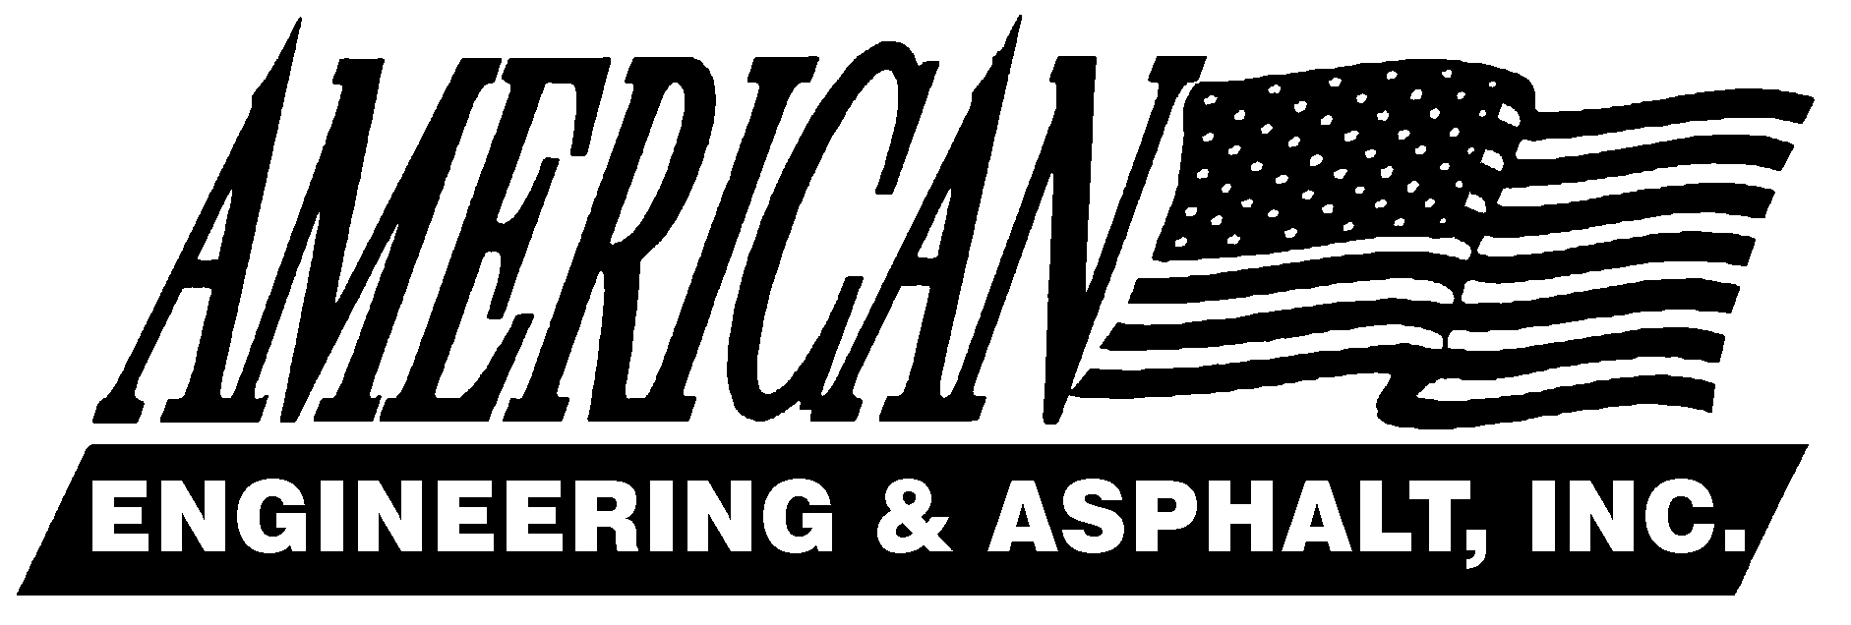______________________________________________________________________________________________________
4175 Cincinnati Ave.
Rocklin, CA 95765
Phone (916) 577-2047
FAX (916) 577-2095
License #346455

December 10, 2008

Governor Arnold Schwarzenegger
Members, California Legislature
California Air Resources Board

Dear Governor Schwarzenegger, Members of the California State Legislature and CARB:

The California Air Resources Board (CARB) is currently considering the adoption of an on-road diesel truck and bus regulation that, if implemented as presently drafted would have a profound, negative impact on California’s economy.

I want to be clear: American Engineering & Asphalt, Inc. is very supportive of reducing particulate matter (PM) and NOx emissions from diesel engines. There is no disagreement that we need to work collectively to improve the state’s air quality and all of us want to provide as healthy an environment as possible for our families, our employees and all Californians. However, in its current form, the Board’s proposed regulation places a significant economic risk on our business today, jeopardizes our future viability in the construction industry, which is already reeling from unprecedented financial turmoil.

CARB is proposing this multi-billion dollar regulation during the worst economic crisis since the Great Depression. California truckers, construction companies and bus operators are struggling to make ends meet in the face of a massive slow down in the construction sector due to falling home prices and home foreclosures, declining consumer confidence and spending and a freeze in the credit markets. Today there is virtually no access to capital for businesses, large and small.

Companies like ours are being asked to dispose of equipment and assets before their useful life has been completed and purchase new equipment before it would otherwise be acquired. A combination of this proposed rule and the state of the economy have left the trade-in or resale value of our equipment worth pennies on the dollar. Our company and others like us simply don’t have the resources or access to capital to retrofit our engines. Some of us may be forced to sell off our trucks at a loss or shutter our companies’ doors, ultimately costing jobs and revenue to the state’s economy.

Many of California’s trucking companies have already begun the process of retrofitting or replacing their fleets, whether in the normal course of their business cycle or in anticipation of these regulations. However, the smaller owner/operators – those with fleets of five trucks or less – who make up more than 55 percent of all trucks registered in the state will be severely hampered by the costs of retrofitting or replacing trucks that, in some cases, are the sole assets of their family-owned businesses.

Given the multi-billion dollar cost of this regulation – and the current volatile economic environment - I urge you to support the alternative proposal proposed by the Driving Toward a Cleaner California (DTCC) Coalition that would give companies like ours the opportunity to comply in the most reasonable timeframe and flexible manner possible while still attaining aggressive emission reductions.

In fact, CARB’s own analysis of the DTCC alternative confirms that the DTCC alternative proposal achieves roughly similar emissions benefits to the proposed regulation in the long-term.

We must be careful not to forfeit California’s economy and ability to move goods across the state, build construction projects and bus our children to and from school for the sake of protecting our environment. We look forward to working with you, CARB, environmental organizations, the Legislature and other stakeholders to accomplish these goals.

Sincerely,

David Bacchi
Safety Officer
American Engineering & Asphalt, Inc.
4175 Cincinnati Ave
Rocklin CA 95765

