CALIFORNIA TOW TRUCK ASSOCIATION
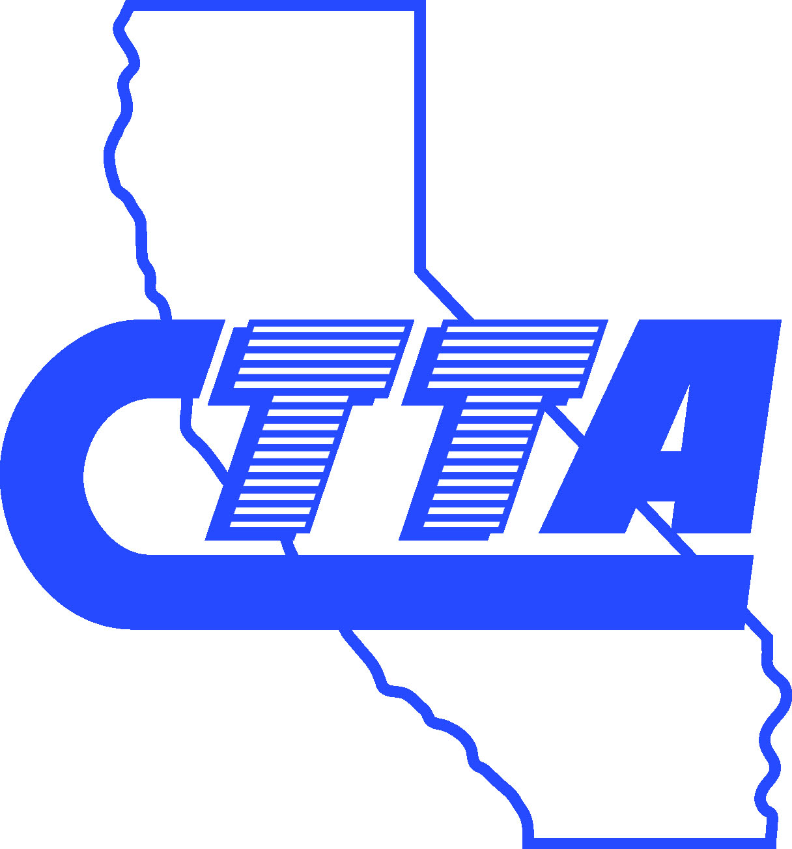

“Developing Professionalism in the Towing Industry”

3001 E. Tahquitz Canyon Way, Suite 108
Palm Springs, CA 92262-6900

Telephone: (760) 325-5840 Facsimile: (760) 325-5843

www.ctta.com

December 11, 2008

Ms. Mary Nichols
Chairwoman, California Air Resources Board
1001 I Street
P.O. Box 2815
Sacramento, CA 95812

Re: CTTA Written Comment on ARB’s Proposed Regulation for On-road Diesel Vehicles

Dear Chairwoman Nichols:

On behalf of the membership of the California Tow Truck Association (CTTA) we are writing to express our deep concern with the California Air Resources Board (ARB)’s Proposed Regulation for In-use On-Road Heavy-duty Diesel-fueled Vehicles. We would also like to state our strong support for the Alternative Proposal presented by the Driving Toward a Cleaner California (DTCC), of which CTTA is a member.

Founded in 1969, the California Tow Truck Association represents over 1,000 towing companies within the state of California, providing vital services to the state’s motoring public. Our members employ approximately 15,000 people across the state.

While CTTA is generally supportive of efforts to clean our state’s air, this proposed regulation will have dire financial implications upon our industry, at a time when our industry can least afford it. The economic reality will be a shortage of tow trucks being able to respond to minor and major traffic incidents throughout the state further complicating the traffic grid lock the state already faces. As a result, the safety our state’s motoring public will be jeopardized. The accelerated timelines proposed for truck turnover far exceed the natural turnover of our tow trucks, which will inevitably cause professional operators to close their doors and cease operation because of a financial inability to survive. The bleak economy is already crushing many of these professionals in our industry. Sadly, many of these good operators perform vital towing services for various law enforcement entities across the state, providing crucial assistance with ensuring the safety of our motoring public. Without these operators, law enforcement personnel will not be able to adequately protect our citizenship – yet the Staff Report incorrectly concludes that “state agencies would not be affected” by the regulation. (ISOR, p. 53)

Particularly impacted are the heavy heavy-duty trucks (greater than 33,000 GVWR) in our industry. These low-mileage vehicles (traditionally drive less than 30,000 miles per year) are utilized to clean-up the most disastrous accidents on our roadways. With so few miles driven and such a huge cost of replacement (they contain hundred of thousands of dollars in specialty equipment), these trucks understandably tend to be replaced at a slower pace than smaller tow trucks. Yet, with proper maintenance these trucks can continue to operate cleanly and with much less environmental impact than high-mileage vehicles.

Unfortunately, the current proposed regulation contains no accommodations for these heavy heavy-duty vehicles. Our members have mortgages on these trucks, and their business model is based on the assumption that they can get years of service out of the vehicles. To require our members to discontinue the use of these trucks prior to the end of their useful life will spell financial disaster for most of our members. They simply cannot afford to transition to newer vehicles in such a short time. The result will be that many of our businesses will close, and thousands of jobs will be lost at a time when California’s unemployment rate is already approaching record highs.

Another direct effect of imposition of the rule will be disastrous results on our highways and roads. With fewer heavy duty tow truck operators remaining in business, roads will remain uncleared, traffic will back up, vehicle emissions will increase, and our economy and environment will be further harmed. It is ironic that the very air the rule is designed to help clean will actually be become even more polluted.

The Alternative Proposal presented by DTCC resolves many of these problems that our industry will experience while achieving the same long-term emissions reductions. Primarily the Alternative Proposal seeks more flexibility for low-mileage vehicles, as well as accommodations for dedicated specialty use vehicles such as tow trucks. We strongly urge the Board to adopt this proposal, as the livelihood of our industry – and thus, the safety of our motoring public – is on the line.

Thank you for your consideration. Please contact me should you have any further questions.

Sincerely,

Glenn Neal
President, CTTA

CC: Air Resources Board Members:
John R. Balmes, M.D. Ms. Sandra Berg
Ms. Dorene D'Adamo
Mr. Jerry Hill
Ms. Lydia H. Kennard
The Hon. Ronald O. Loveridge
Mrs. Barbara Riordan
The Hon. Ron Roberts
Mr. Daniel Sperling
John G. Telles, M.D.

