

July 21, 2009

Chairman Mary Nichols
California Air Resources Board
1001 I Street, P.O. Box 2815
Sacramento, CA 95812-2815

Dear Chairman Nichols:

The California Transit Association supports the recommendation that the Air Resources Board defer the 15% purchase requirement of Zero-Emission Buses (ZEB) in California’s transit fleets.

The life cycle costs of the advanced technology buses and the cost associated with building a hydrogen infrastructure are extraordinary. The current cost of a hydrogen fuel cell bus is roughly $2 million, four times that of a comparable diesel or compressed natural gas bus. Moreover, fuel cells must be replaced at least once during the life of a bus at a current cost of $1 million per fuel cell. Batteries pose another problem altogether, both because of limited options available and because the battery life has proven to be disappointing. In addition, the fueling stations and maintenance facilities may cost well over $10 million and $5 million respectively per facility. These costs are simply too much for a public mass transit provider to bear, particularly in these economic times.

The Governor and the legislature have eliminated critical state funding for transit operations for the next 5 years. This devastating decision compounds a steady decline in state transit support over the last decade. Over $5 billion in state transit funds have been diverted for other purposes since 2000. Systems throughout the state are raising fares and drastically cutting service as a result of the dire economic situation. Most transit operators in California also defer maintenance in order to maintain transit service. This has come at the cost of deteriorating infrastructure resulting in operating inefficiencies and potentially unsafe conditions for transit riders and employees. Even now the Bay Area advanced demonstration project, which is a collaboration of multiple transit systems and regional Bay Area agencies, finds itself with a need for further funding to complete the next phase of the project. The latest capital budget of the Bay Area Zero Emission Bus Advanced Demonstration Project is creeping up to $50 million, $8 million more than the agencies have been able to raise to date.

We offer the following points for your consideration as you make your decision on this issue:

- Due to the costs of current ZEB technology, as well as the reliability and durability challenges ZEB technology currently faces, we support the recommendation that the 15% purchase requirement be deferred.

- As a result of the current severe financial constraints facing transit, we have concerns about our agencies’ ability to accommodate a new demonstration program. We simply cannot make an additional demonstration program a reality unless more funding is made available to cover the substantial costs that an added demonstration program will require.

- If your Board votes to implement the use of performance measures or “implementation criteria” to “trigger” the purchase requirement in the future, our Association has strong concerns about the criteria presented in 2006 and puts forward that it is essential that these criteria be re-evaluated. Our Association is happy to work with your staff to further develop these criteria.

- A gradual phase-in of a purchase requirement will be harmful to our agencies if the phase-in begins before the implementation criteria are fully met. If a phase-in were to happen before the criteria are fully met, it would put unreliable buses into service, and incur enormous costs for infrastructure to support these buses. This would be detrimental to our transit agencies in light of the economic crisis already facing the industry.

We would like to thank your staff for their work on this issue over the last several months, and for working with our Association members in this process. Our Association supports the Board’s goals of cleaning California’s air and reducing vehicle emissions through use of the latest technology. We strongly encourage that this technology not be deployed until it is operations-ready and affordable to our agencies. We are happy to continue to work with your staff in furthering the ZEB program, and in finding a more feasible timeline to implement this technology into our transit fleets.

Thank you for your time and consideration.

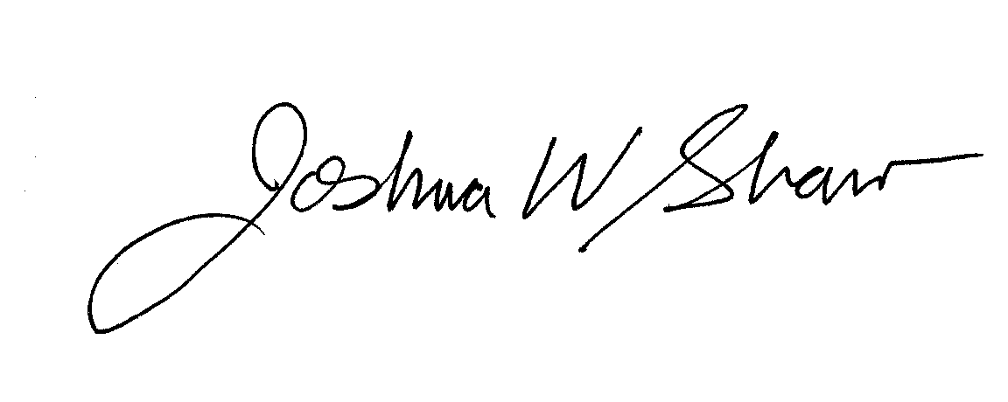
Sincerely,

Joshua W. Shaw, Executive Director
California Transit Association

