National Hydrogen Association
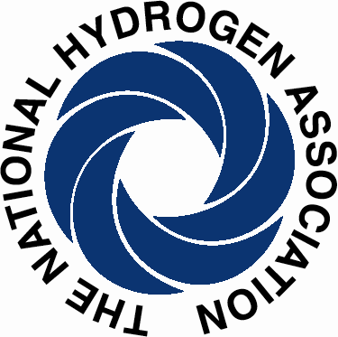

December 8, 2009

State of California Air Resources Board
1001 "I" Street
P.O. Box 2815
Sacramento, CA 95812

Dear CARB:

I write on behalf of the over 80 members of the National Hydrogen Association (NHA) to express our strong support for the Zero Emission Vehicle (ZEV) Program and the findings released by the ARB staff in their preliminary assessment of the need for revisions to the ZEV regulation. Generally, the staff recommendations are very well thought out, complete and well balanced. Their ideas and preparations will serve as key points of departure for the work they have laid out for themselves in the coming months. Through the several workshops they plan, we hope that many of our industry members will have a chance to make their voices heard, improve staff analyses and yield superior recommendations to the ARB about ZEV program design in the months ahead.

The NHA strongly supports the stronger focus on the carbon reduction aspects of ZEVs, and recommends that the legislated definition of ZEVs include this factor, in addition to criteria pollutants. Through deployment of ZEVs and their accompanying energy supply infrastructure, we agree that the transportation sector has superb potential to sharply lower GHG emissions in the 2040-2050 time frame. It will take sustained hard work and considerable investment to accomplish this, but hydrogen is a well known industrial gas, a great deal is produced in California already, low carbon manufacturing processes are well known, and plant gate costs are already competitive with gasoline.

The right mix of complementary policies and use of the Clean Fuels Outlet authority are critical to achieving market development in the magnitude required to realize dramatic drops in GHG emissions. NHA is pursuing in Congress a family of initiatives that match tax incentives with state grant infrastructure investments that are designed to work with California’s approach, enabling concerted rollout of ZEVs and refueling infrastructure in a timely fashion—avoiding stranded assets and price volatility, while easing market acceptance for consumers. A new jobs and infrastructure bill may be a useful vehicle for accomplishing this. We do note, however, that the Hydrogen refueling infrastructure tax credit (as with all such TCs) in the American Recovery and Reinvestment Act of 2009 is administered by the U.S. Department of Treasury, not the Department of Energy.

We commend the ARB for its strong and consistent leadership in pursuit of cleaner vehicle technology. It will take concerted action across a range of advanced technologies to accomplish California’s ambitious GHG goals. We believe hydrogen and fuel cells are a critical component of the strategy that will achieve them. Thank you for your efforts, the excellent work of your staff, and this opportunity to comment. For questions, please contact us at hinklej@hydrogenassociation.org, or (202) 261-1307.

Sincerely,

F. Jerome Hinkle
Vice President, Policy and Government Affairs

